Congruence

Definition
# Source: AI Source: Provided by: [Data Path: Persons Table -> ID Column: 1, Name_En Column: Motasem Essam] -> From: [ChatGPT] on [7/25/2026]
Congruence is a geometric relationship between two or more figures that have exactly the same shape and the same size.
Two figures are congruent if one can be transformed into the other using only rigid transformations, such as:
- Translation
- Rotation
- Reflection
These transformations do not change the figure's lengths, angle measures, or overall size.
The symbol for congruence is:
$$\boxed{≅}$$
For example:
$$△ABC≅△DEF$$
means that triangle $ABC$ is congruent to triangle $DEF$.
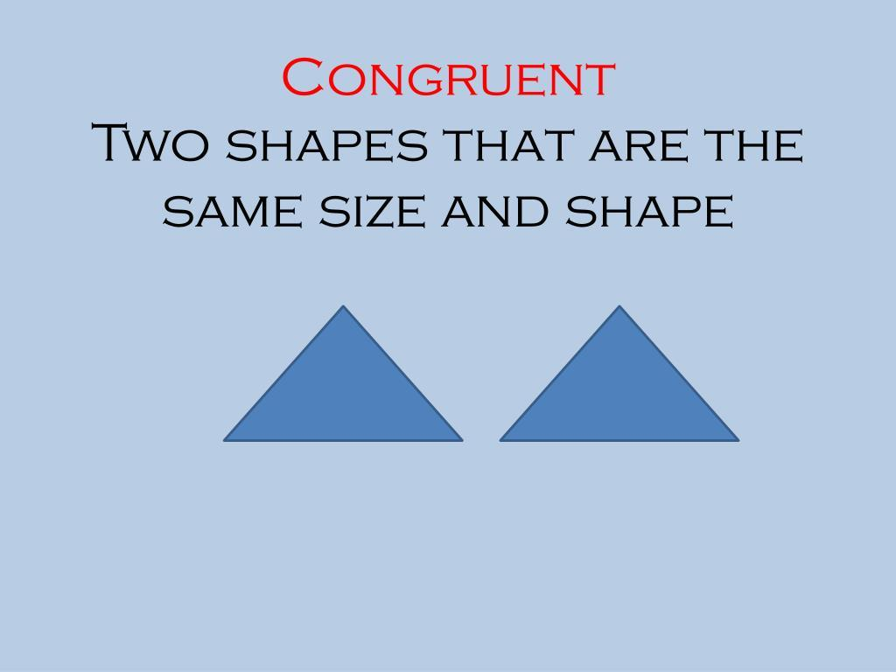
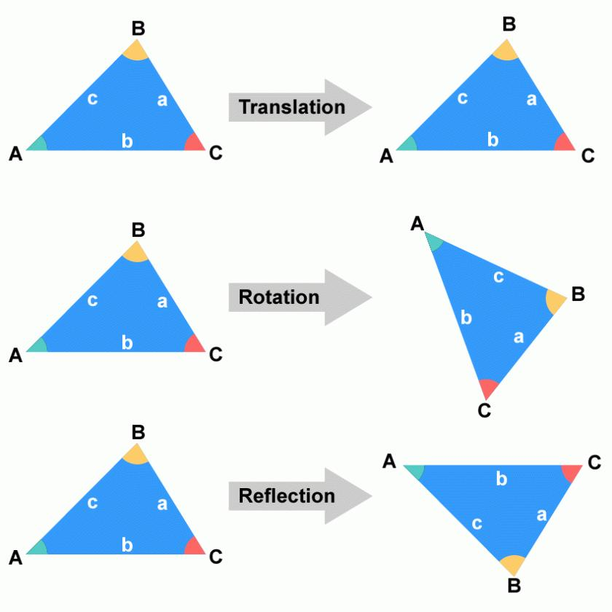
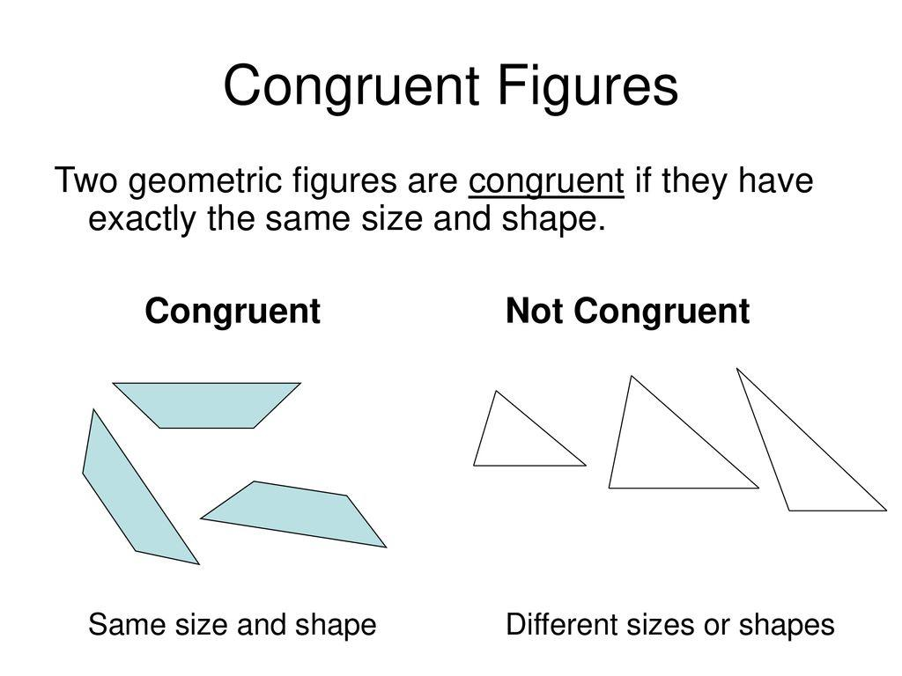
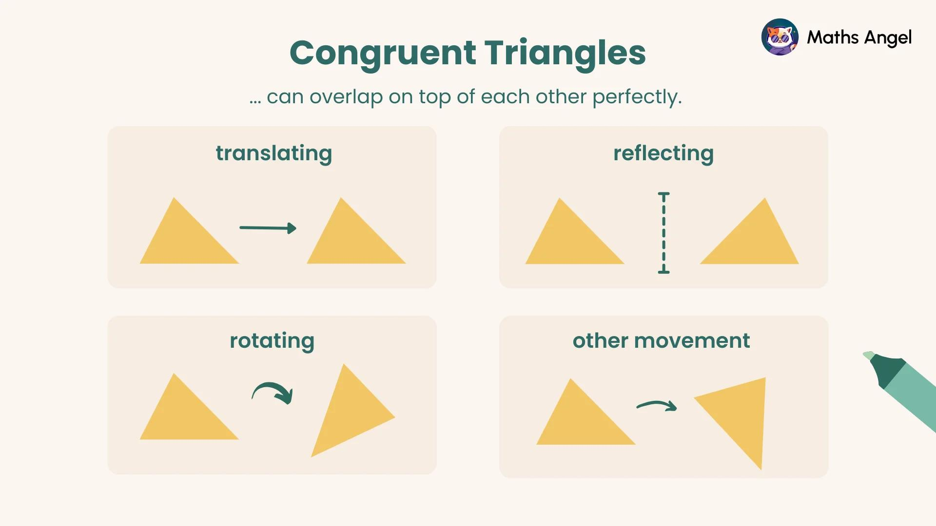
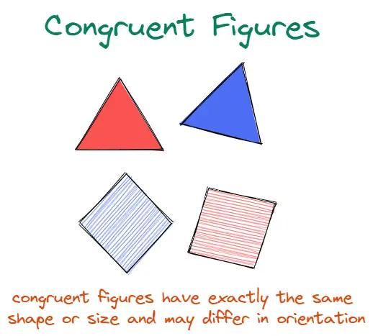
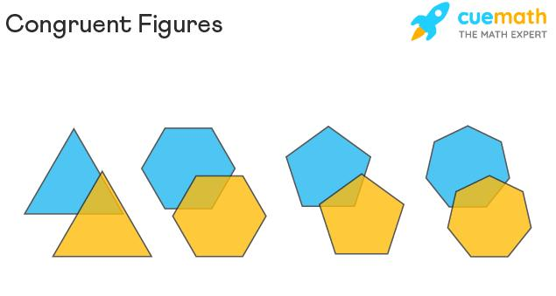

Purpose
# Source: AI Source: Provided by: [Data Path: Persons Table -> ID Column: 1, Name_En Column: Motasem Essam] -> From: [ChatGPT] on [7/25/2026]
Congruence is used to:
- Determine whether two figures have exactly the same shape and size.
- Compare corresponding sides and angles.
- Prove that geometric figures are identical in size and shape.
- Solve geometric construction problems.
- Establish relationships between triangles and polygons.
- Prove geometric theorems.
- Analyze shapes after rigid transformations.

Fundamental Idea of Congruence
# Source: AI Source: Provided by: [Data Path: Persons Table -> ID Column: 1, Name_En Column: Motasem Essam] -> From: [ChatGPT] on [7/25/2026]
Two figures are congruent when their corresponding parts match exactly.
For two congruent figures:
- Corresponding sides have equal lengths.
- Corresponding angles have equal measures.
- Corresponding vertices match.
- Corresponding shapes are identical.
- The figures have the same area.
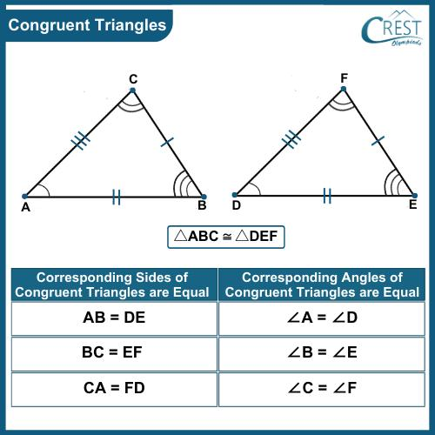
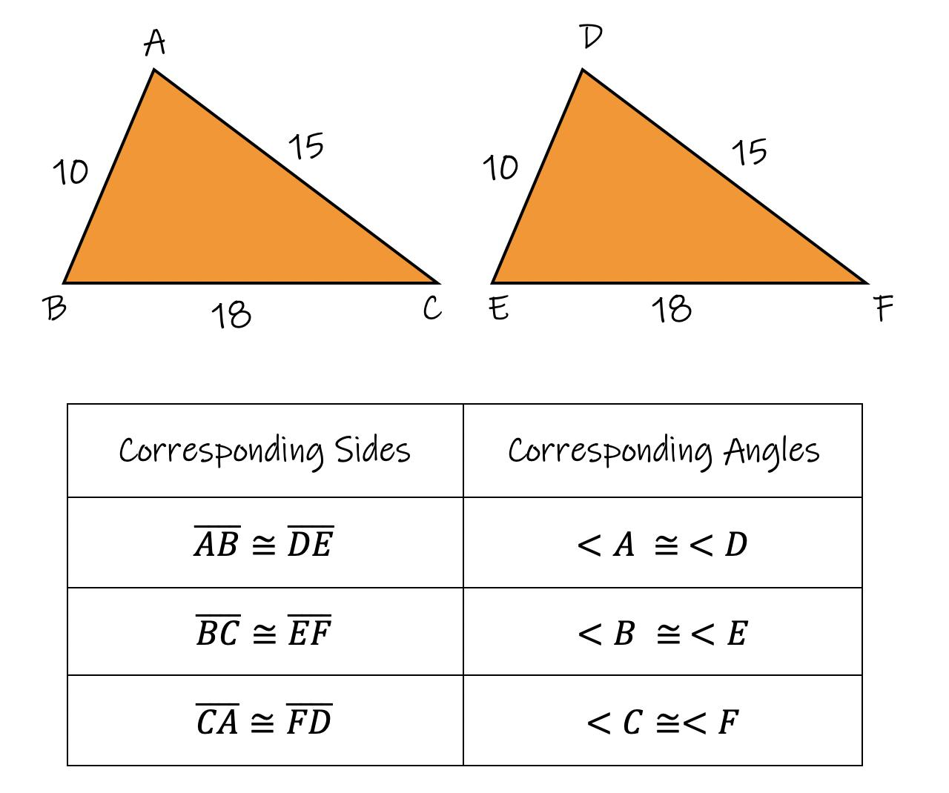
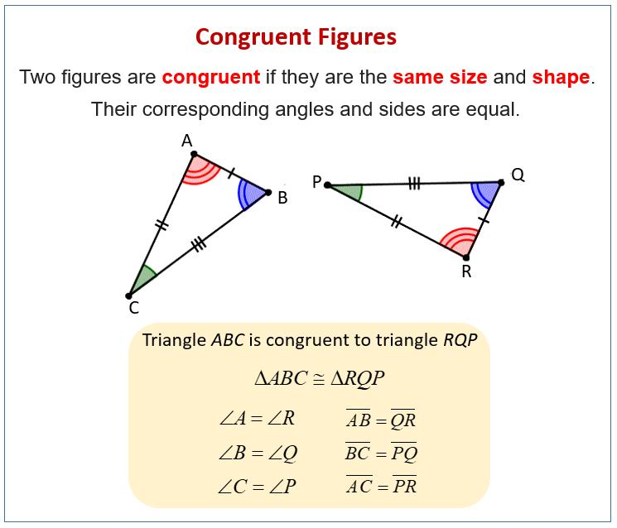
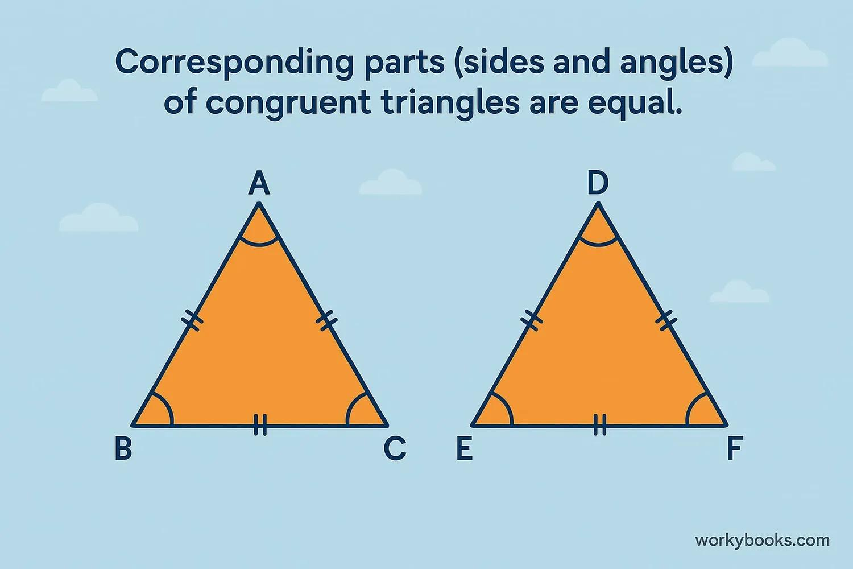
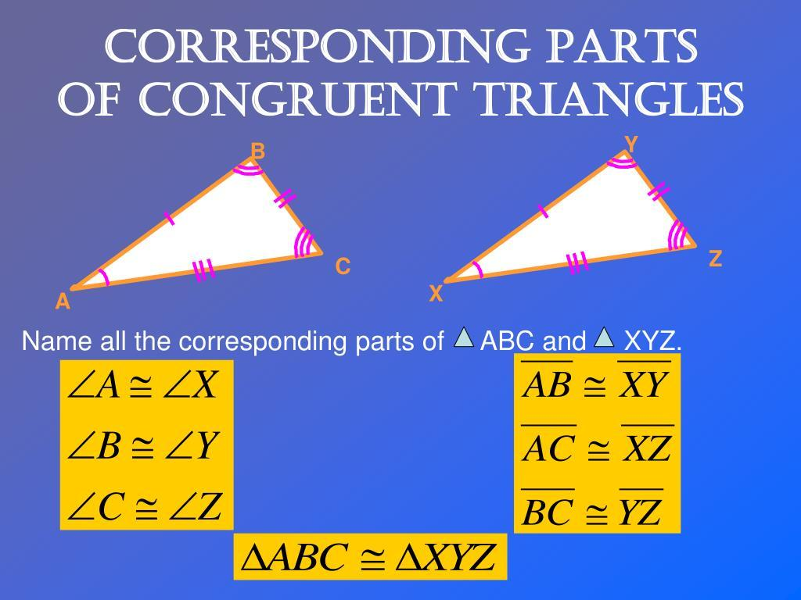
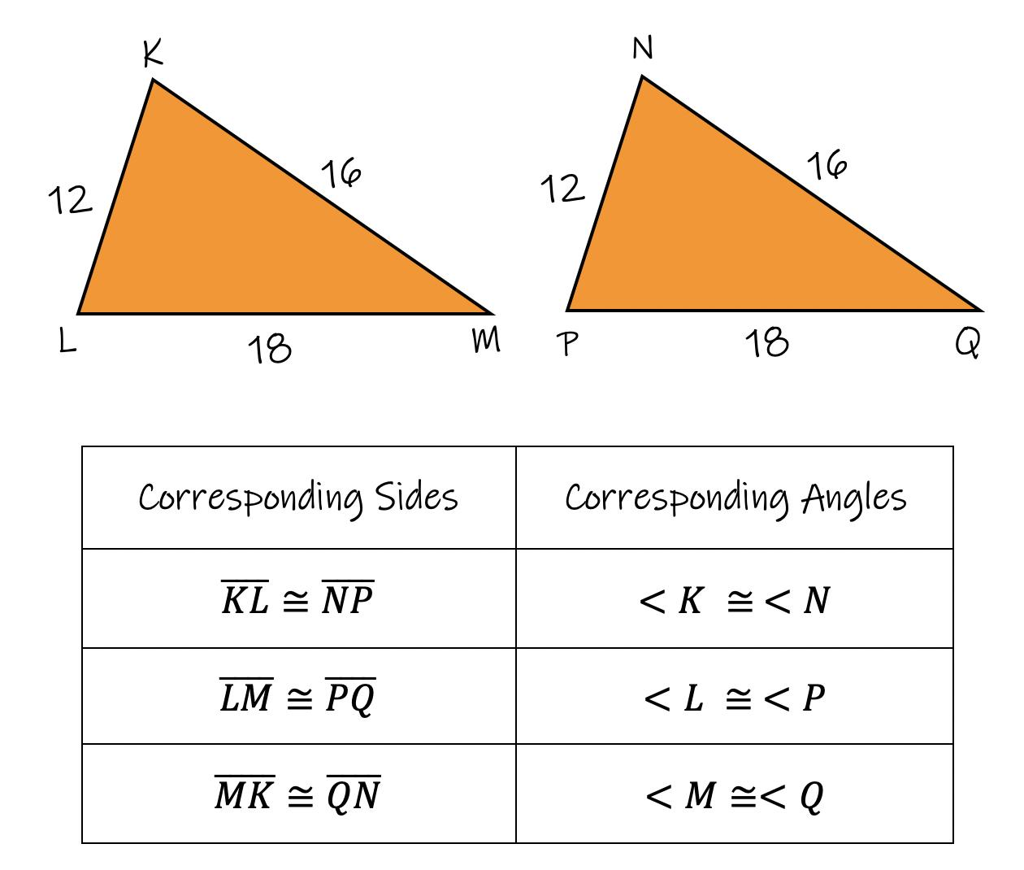

Congruent Figures
# Source: AI Source: Provided by: [Data Path: Persons Table -> ID Column: 1, Name_En Column: Motasem Essam] -> From: [ChatGPT] on [7/25/2026]
Definition
Congruent figures are geometric figures that have exactly the same shape and size, even if they have different positions or orientations.
For example, these two triangles can be congruent even if one is rotated:
$$△ABC≅△DEF$$
The triangles do not need to look identically positioned on the page.
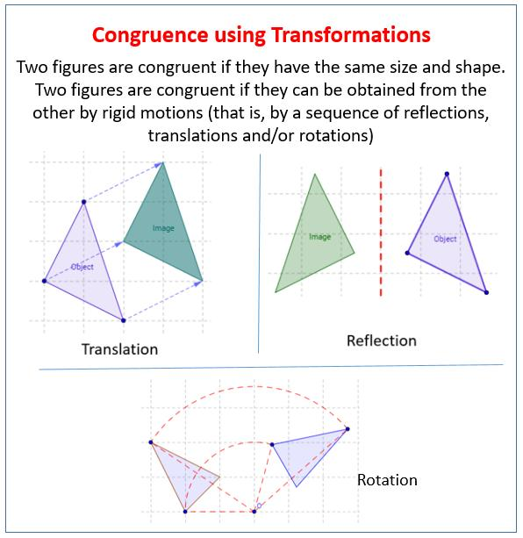
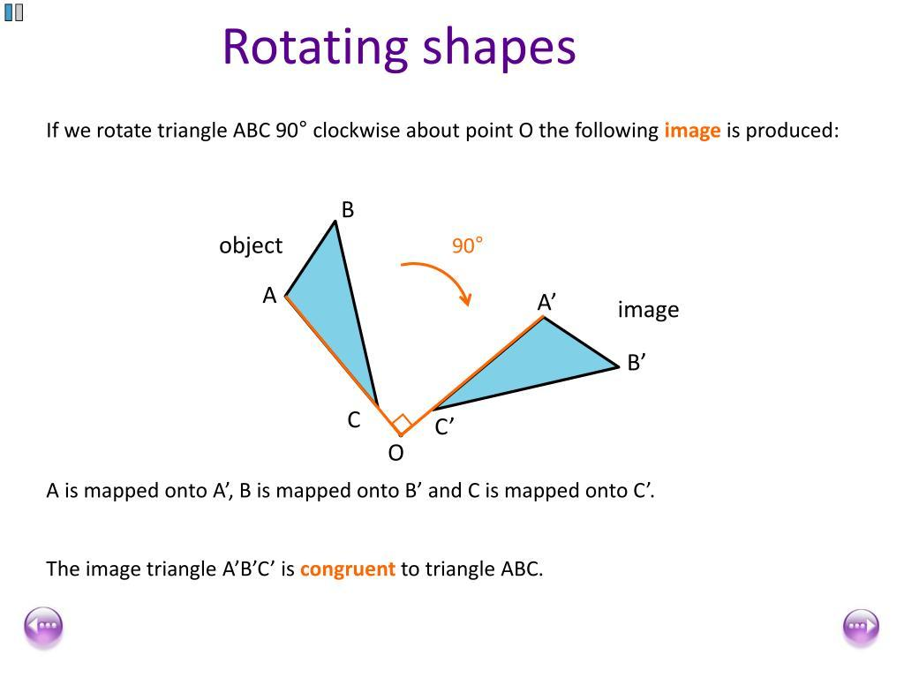
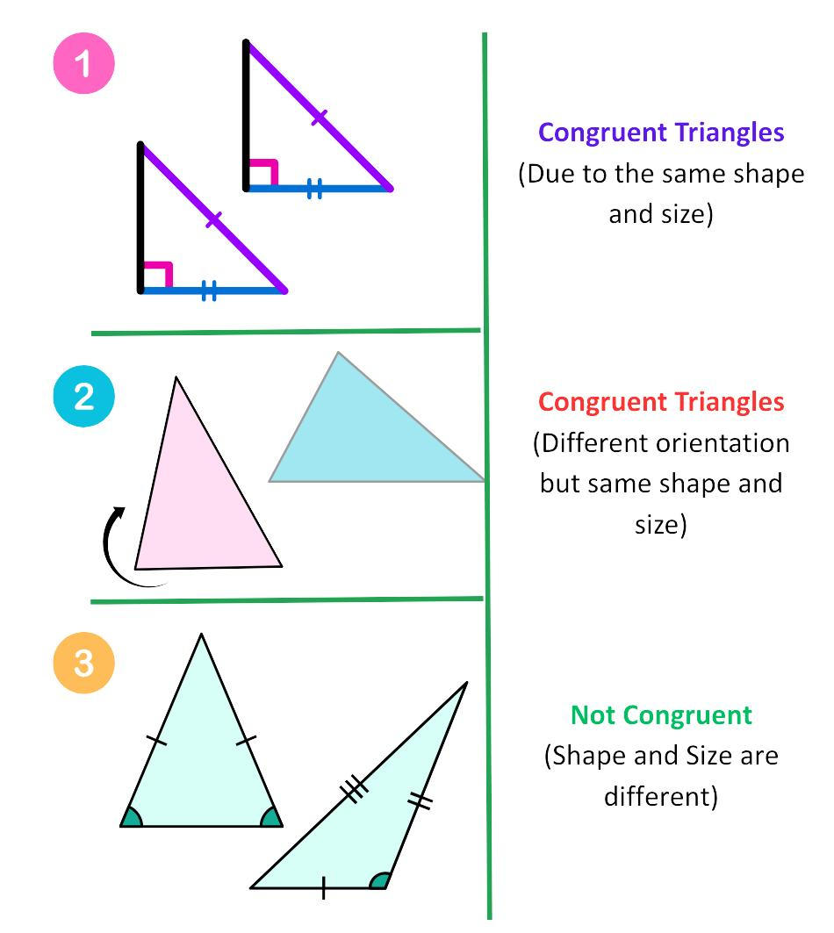
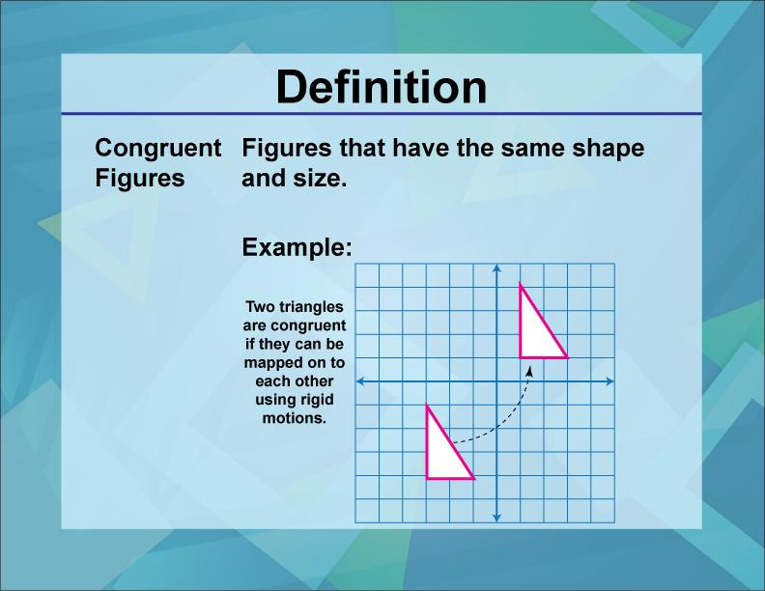

Congruence and Rigid Transformations
# Source: AI Source: Provided by: [Data Path: Persons Table -> ID Column: 1, Name_En Column: Motasem Essam] -> From: [ChatGPT] on [7/25/2026]
Congruence is closely related to rigid transformations.

Translation
# Source: AI Source: Provided by: [Data Path: Persons Table -> ID Column: 1, Name_En Column: Motasem Essam] -> From: [ChatGPT] on [7/25/2026]
Moves a figure without changing its size or shape.
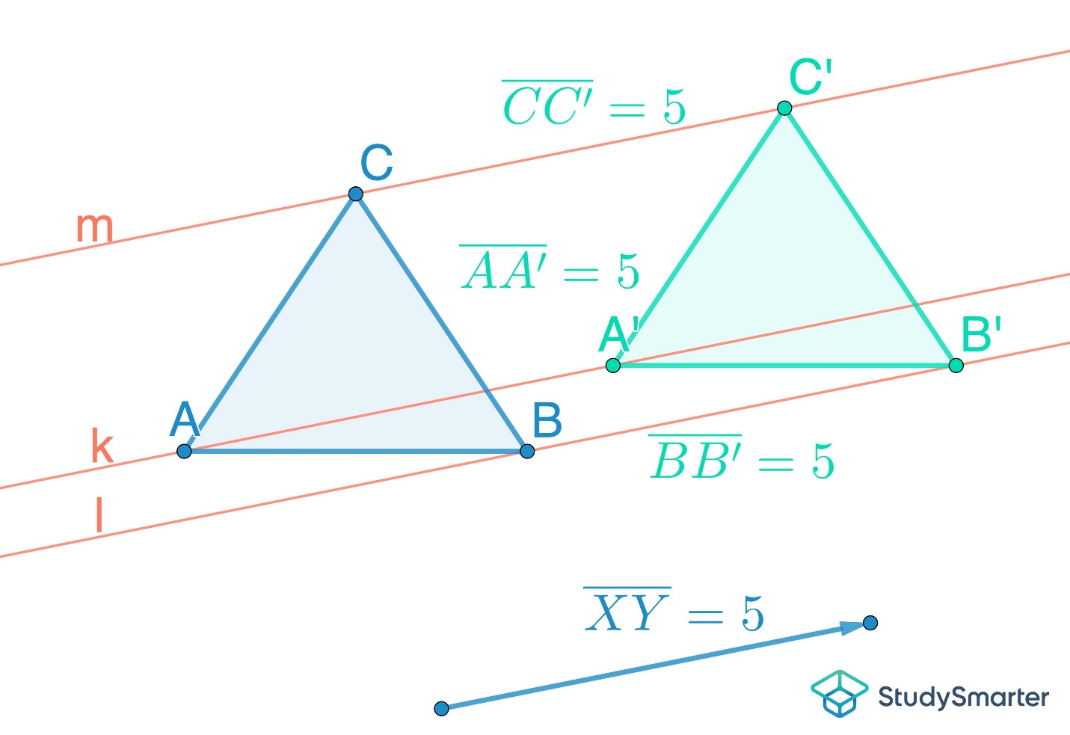
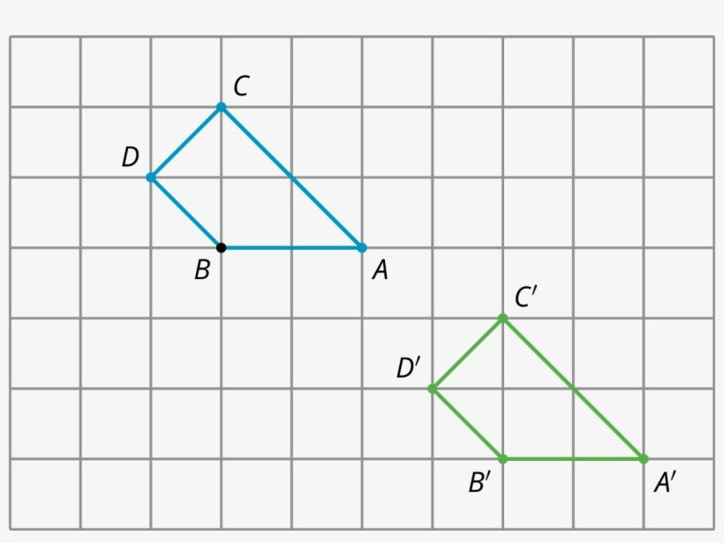
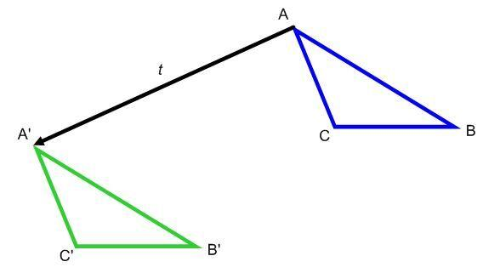
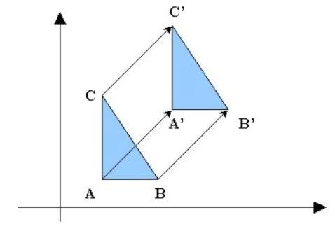
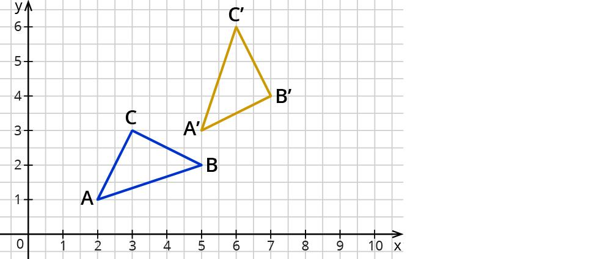

Rotation
# Source: AI Source: Provided by: [Data Path: Persons Table -> ID Column: 1, Name_En Column: Motasem Essam] -> From: [ChatGPT] on [7/25/2026]
Turns a figure around a point without changing its size or shape.
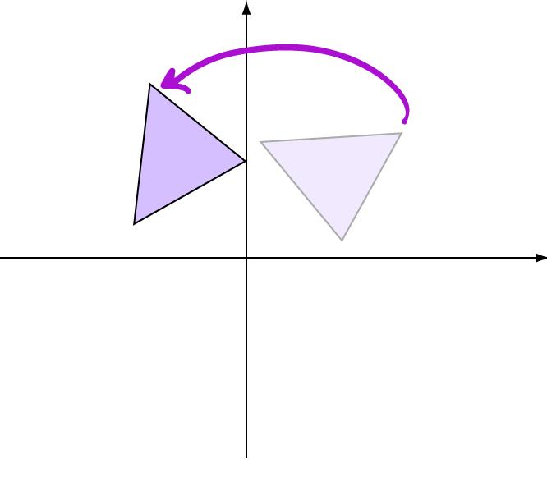
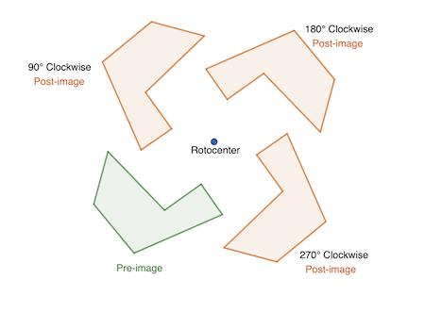
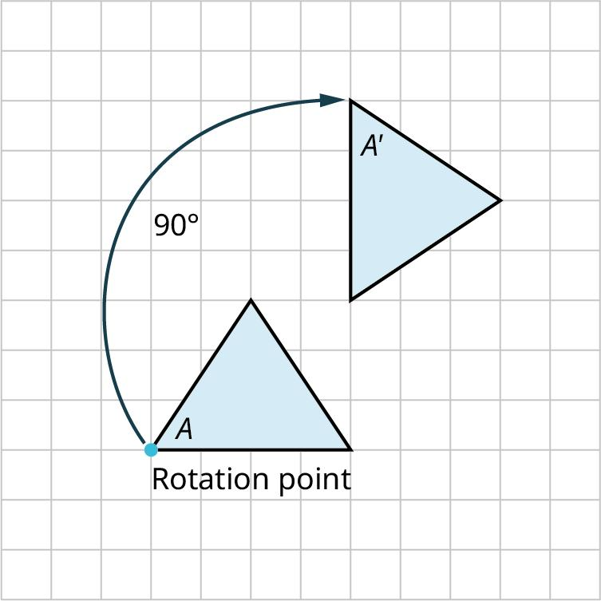

Reflection
# Source: AI Source: Provided by: [Data Path: Persons Table -> ID Column: 1, Name_En Column: Motasem Essam] -> From: [ChatGPT] on [7/25/2026]
Flips a figure across a line without changing its size or shape.
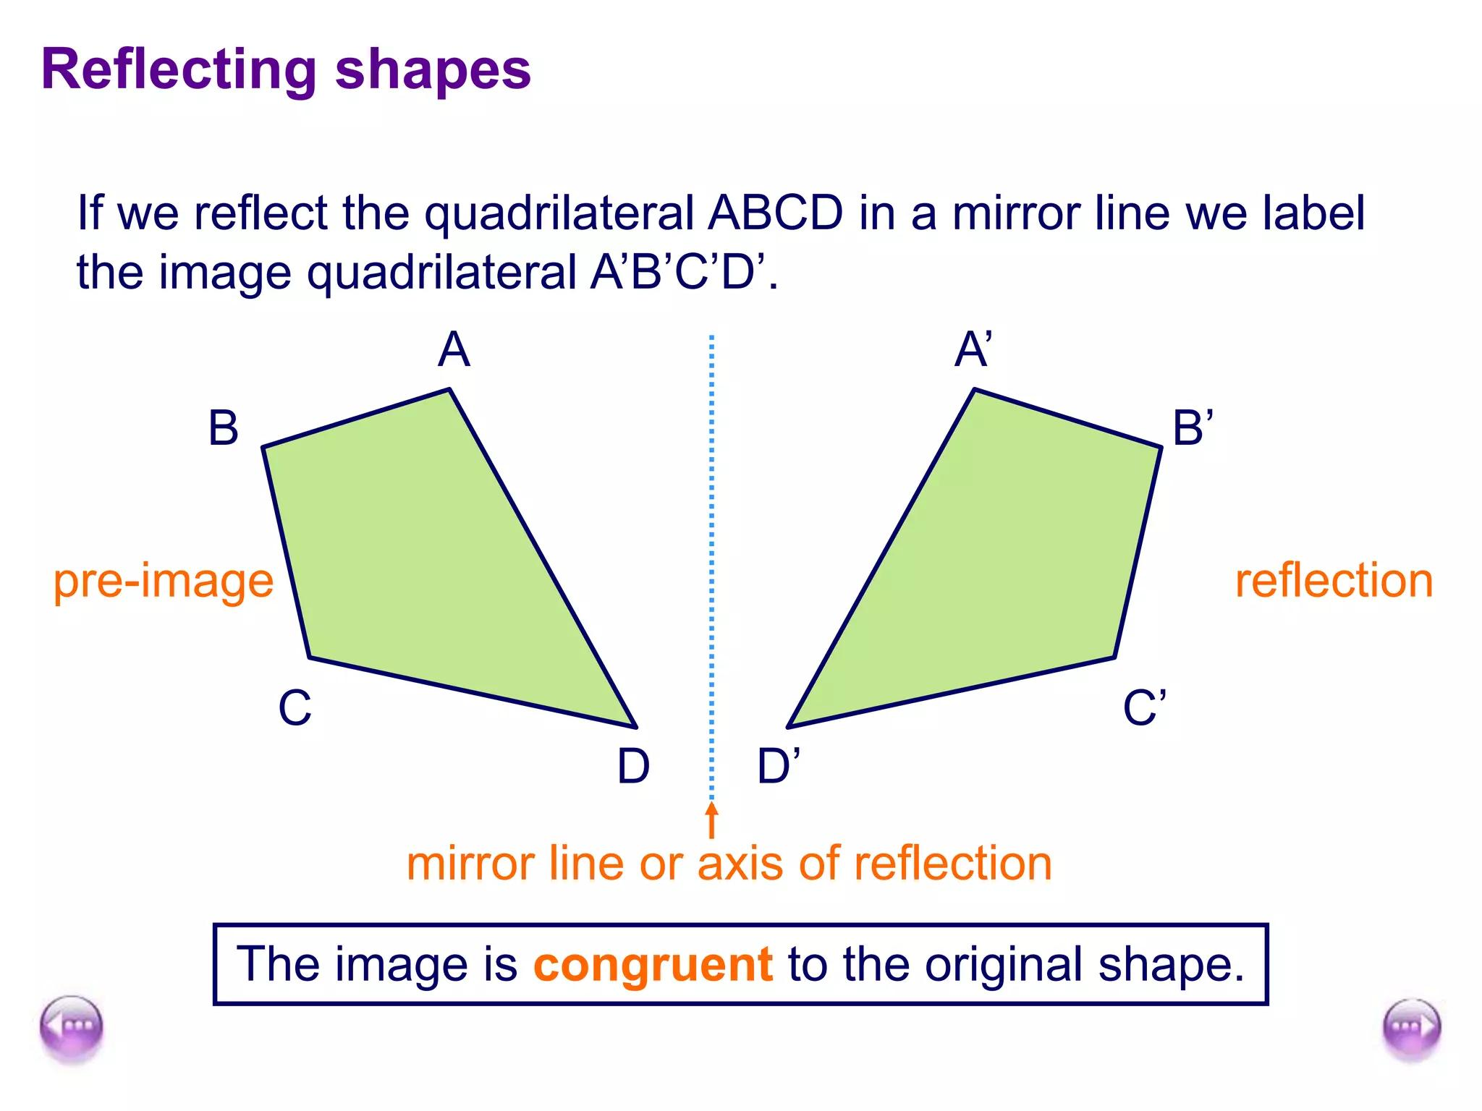
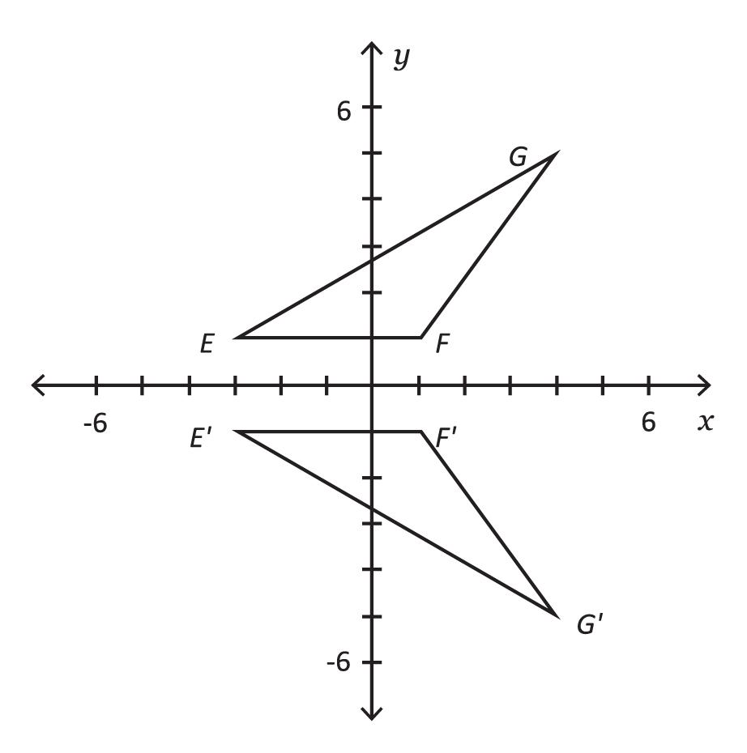
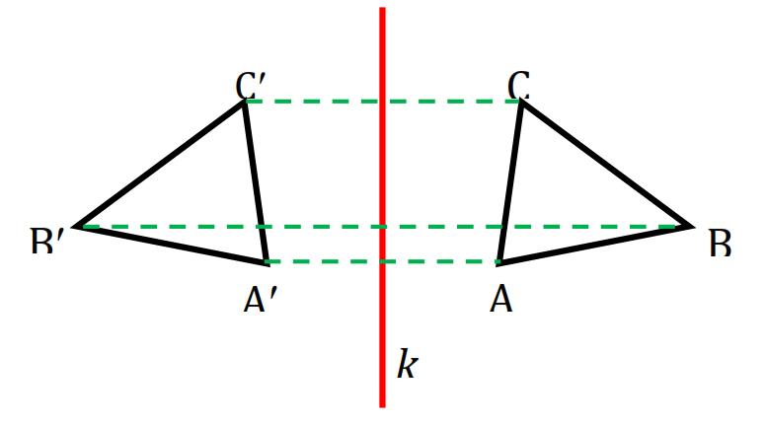
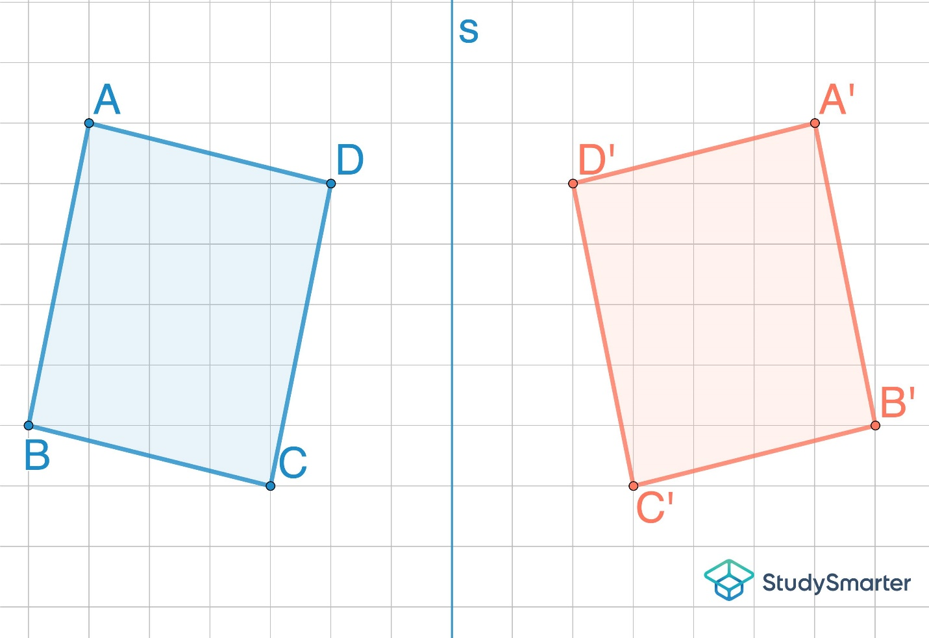
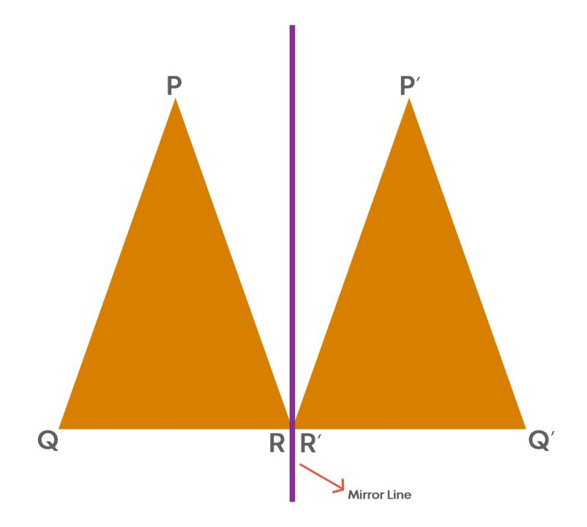
Therefore:
$$\boxed{\text{Rigid Transformation}⇒\text{Congruent Figure}}$$

Congruence of Line Segments
# Source: AI Source: Provided by: [Data Path: Persons Table -> ID Column: 1, Name_En Column: Motasem Essam] -> From: [ChatGPT] on [7/25/2026]
Two line segments are congruent if they have the same length.
For example:
$$\overline{AB}≅\overline{CD}$$
means:
$$AB=CD$$
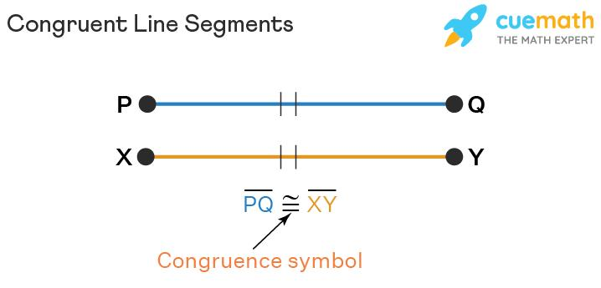
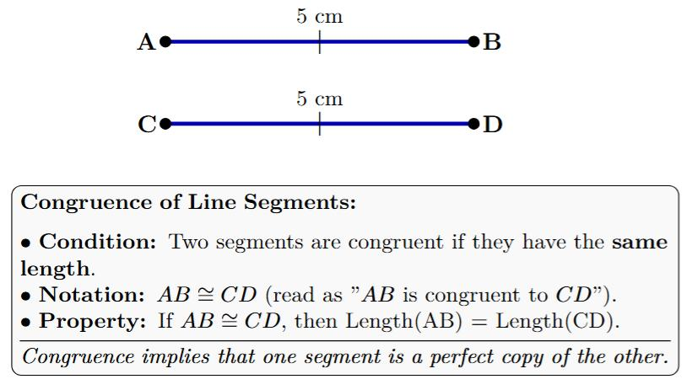
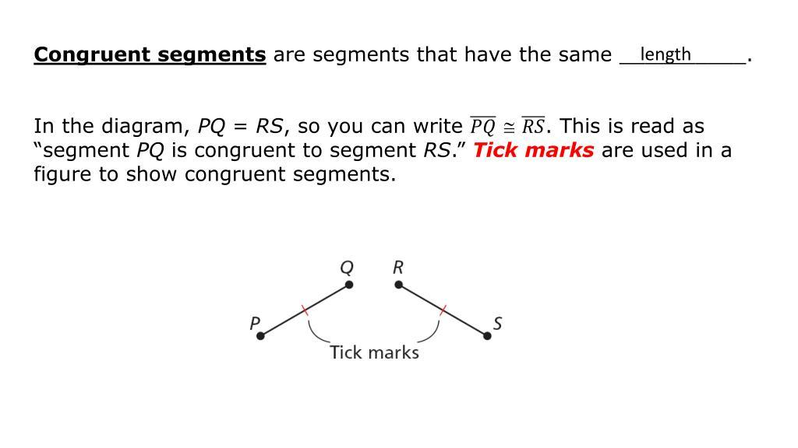
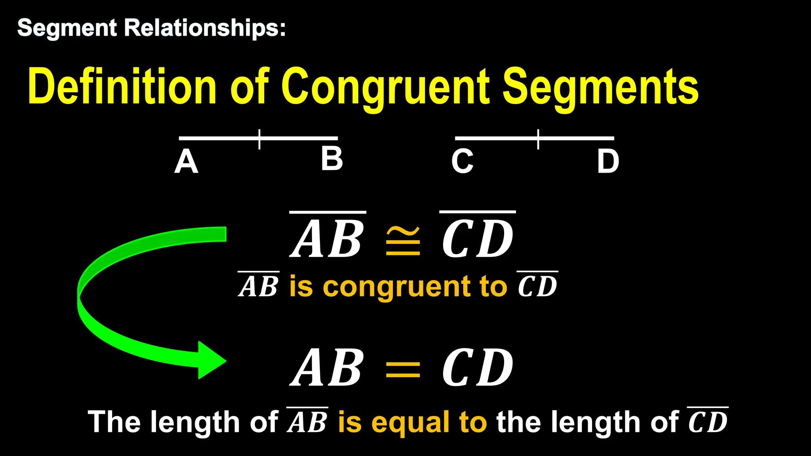

Congruence of Angles
# Source: AI Source: Provided by: [Data Path: Persons Table -> ID Column: 1, Name_En Column: Motasem Essam] -> From: [ChatGPT] on [7/25/2026]
Two angles are congruent if they have the same measure.
For example:
$$∠A≅∠B$$
means:
$$m∠A=m∠B$$
For example:
$$m∠A={60}^{∘}$$
and
$$m∠B={60}^{∘}$$
therefore:
$$∠A≅∠B$$
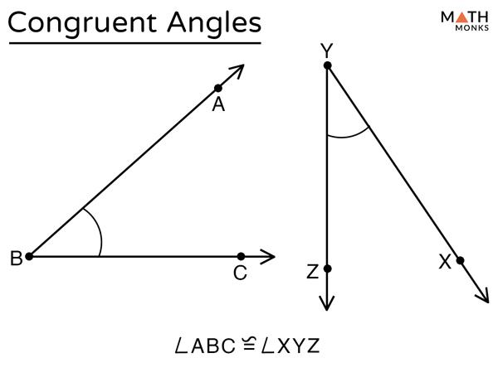
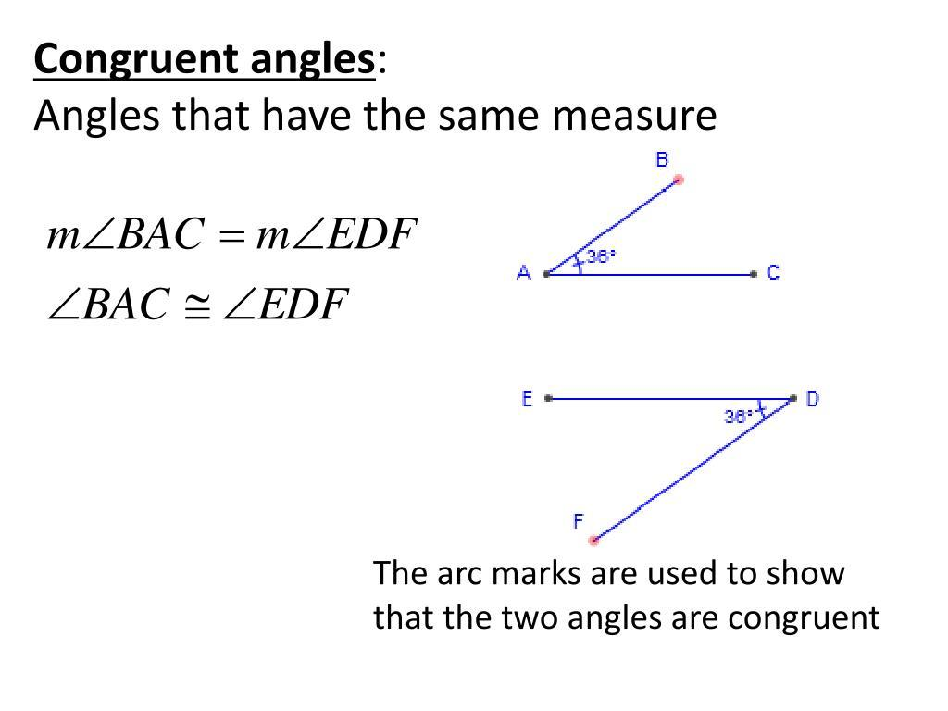
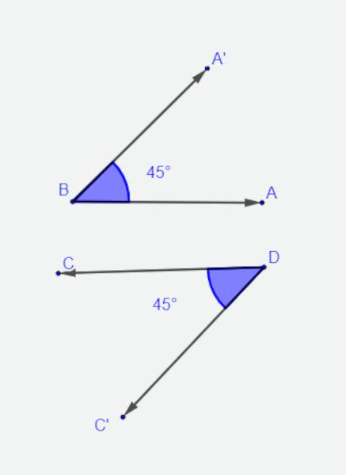
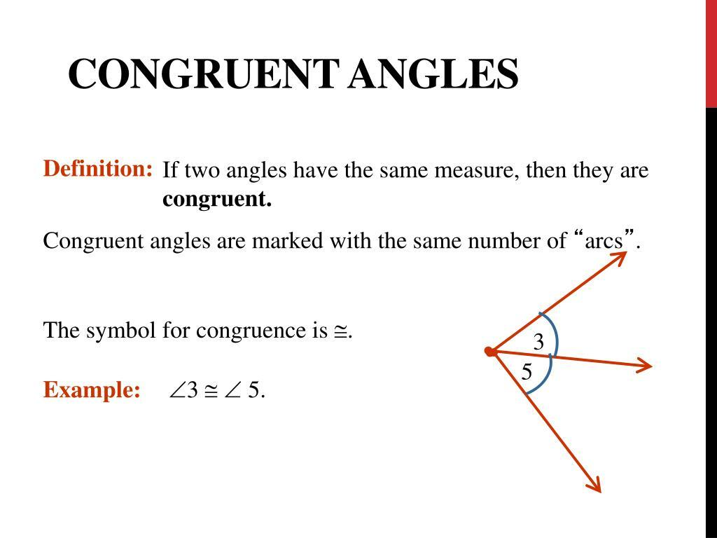
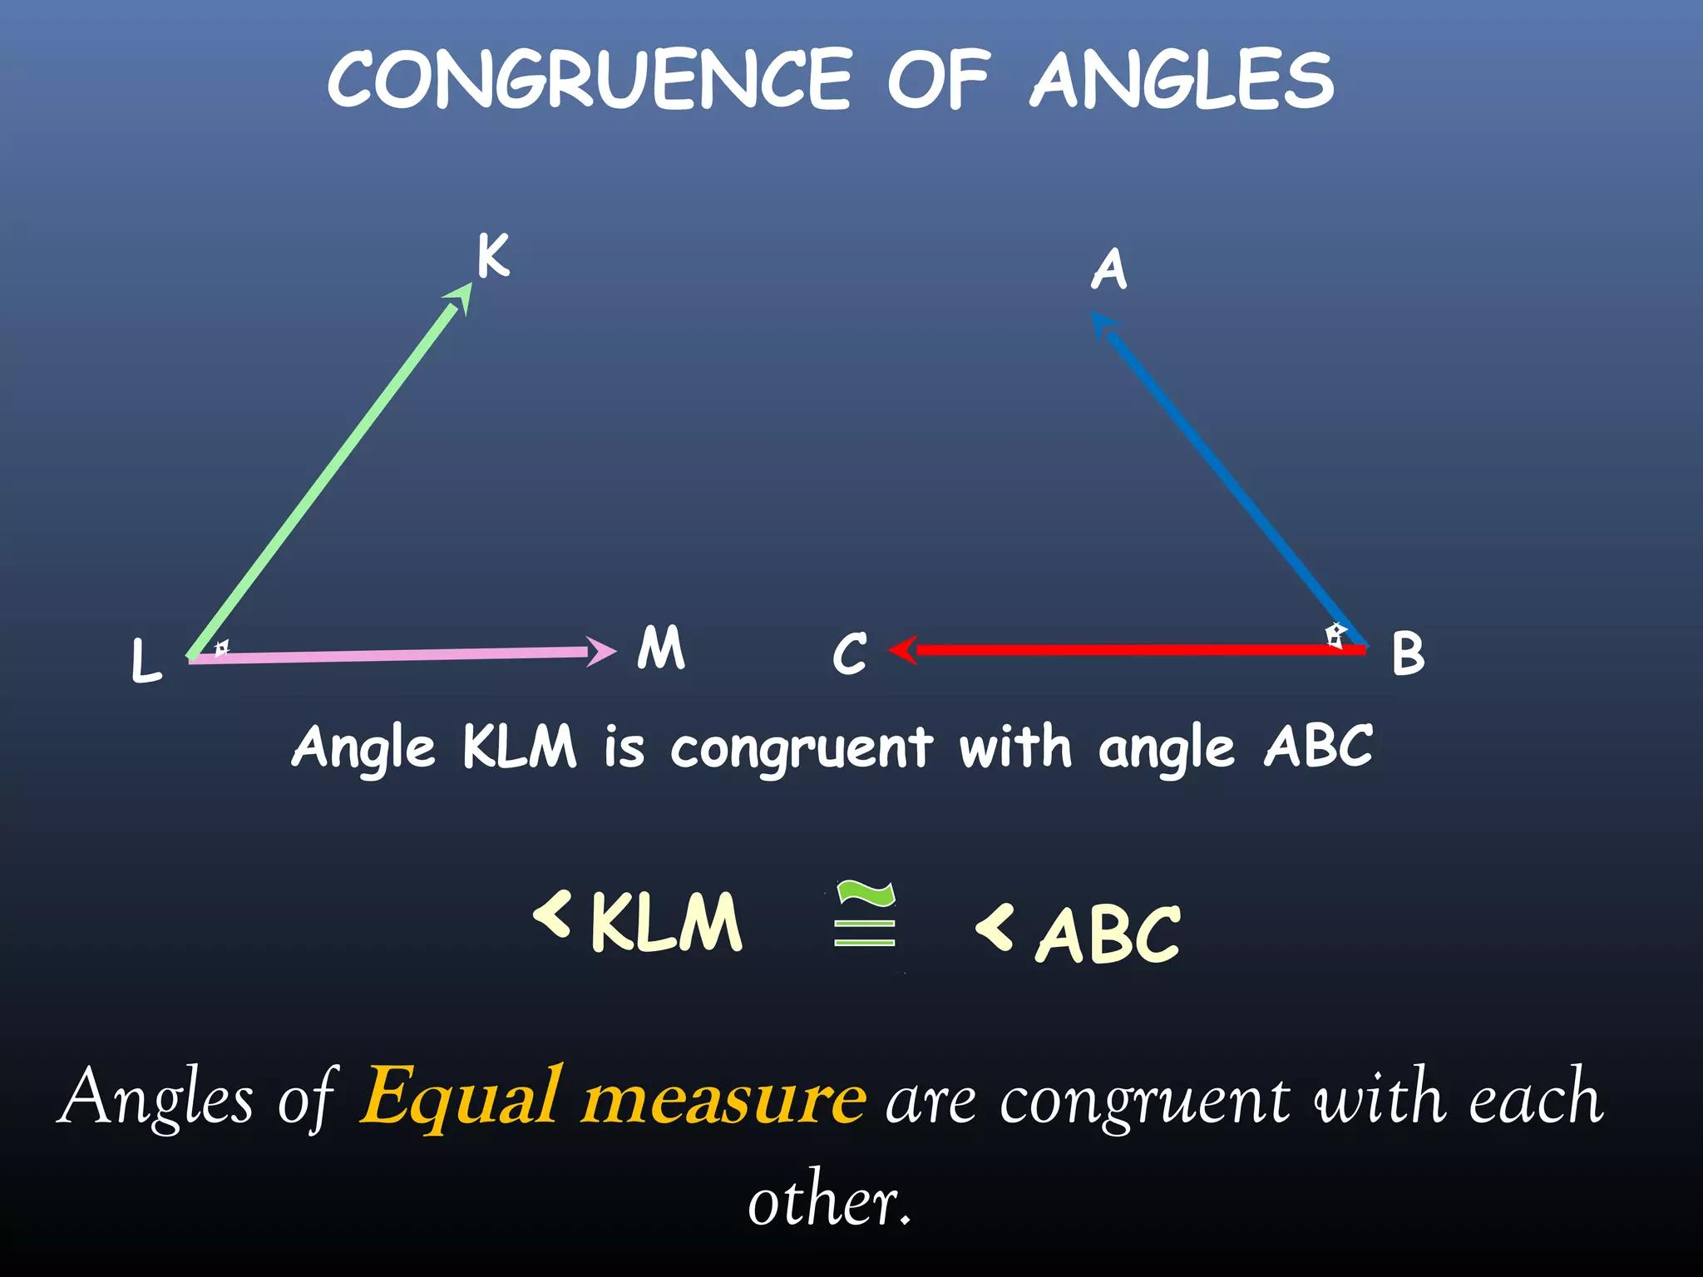

Congruent Triangles
# Source: AI Source: Provided by: [Data Path: Persons Table -> ID Column: 1, Name_En Column: Motasem Essam] -> From: [ChatGPT] on [7/25/2026]
Two triangles are congruent when their corresponding sides and angles match exactly.
For example:
$$△ABC≅△DEF$$
This correspondence means:
$$A↔D \\ B↔E \\ C↔F$$
Therefore:
$$AB=DE \\ BC=EF \\ AC=DF$$
and:
$$∠A=∠D \\ ∠B=∠E \\ ∠C=∠F$$
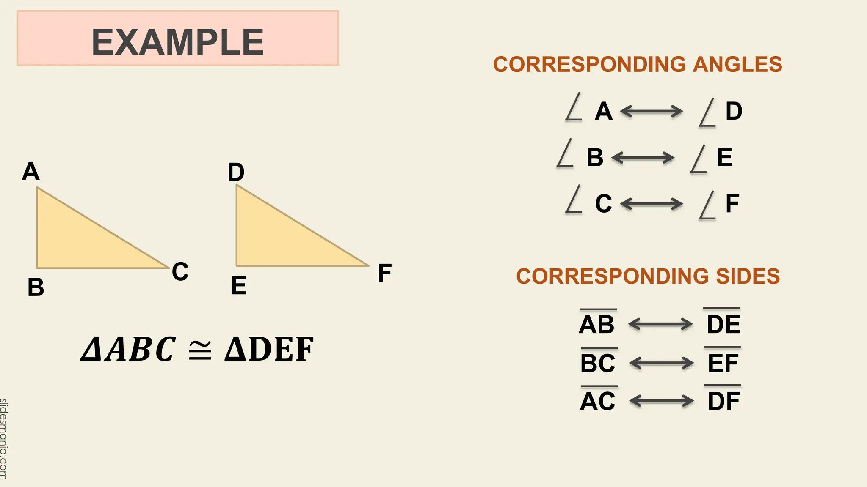
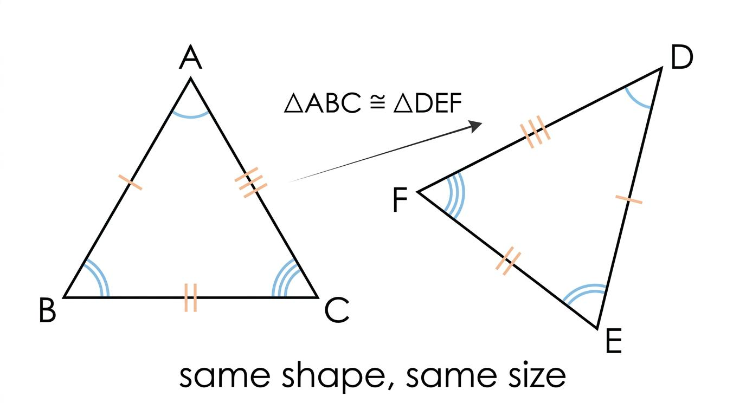
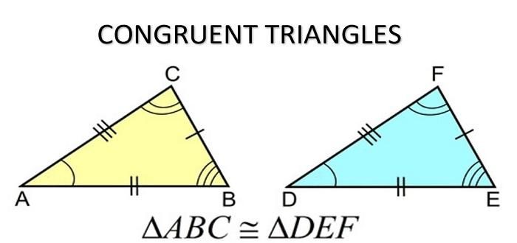

Congruence Criteria for Triangles
# Source: AI Source: Provided by: [Data Path: Persons Table -> ID Column: 1, Name_En Column: Motasem Essam] -> From: [ChatGPT] on [7/25/2026]
There are several important tests for proving that two triangles are congruent.

1. SSS — Side-Side-Side
# Source: AI Source: Provided by: [Data Path: Persons Table -> ID Column: 1, Name_En Column: Motasem Essam] -> From: [ChatGPT] on [7/25/2026]
Two triangles are congruent if all three corresponding sides are equal.
$$\boxed{SSS}$$
If:
$$AB=DE \\ BC=EF \\ AC=DF$$
then:
$$△ABC≅△DEF$$
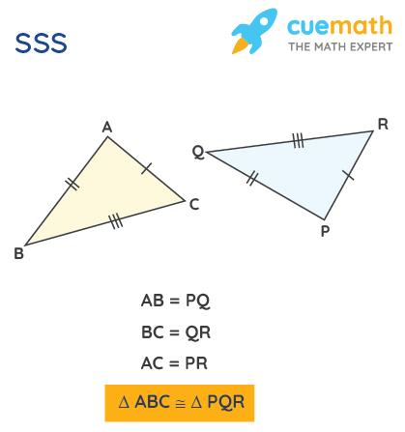
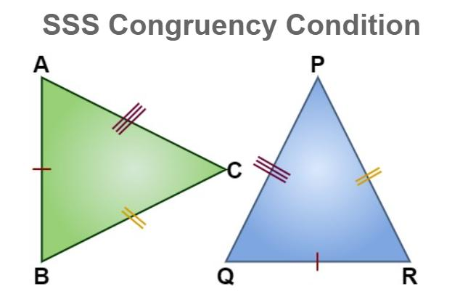
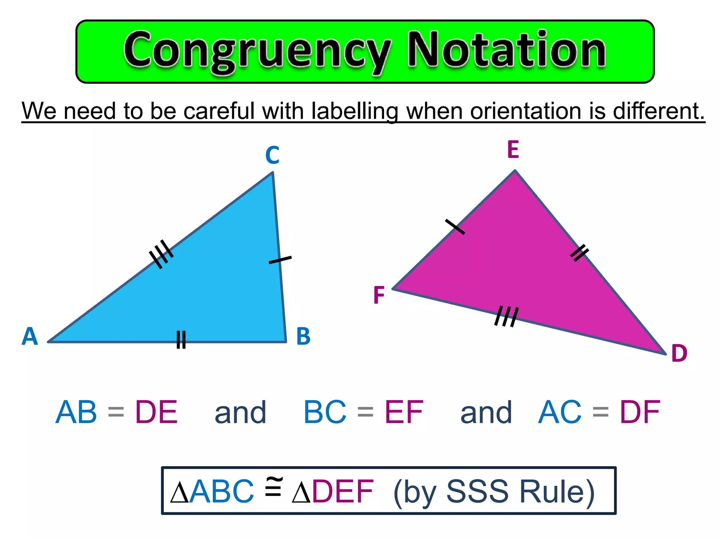
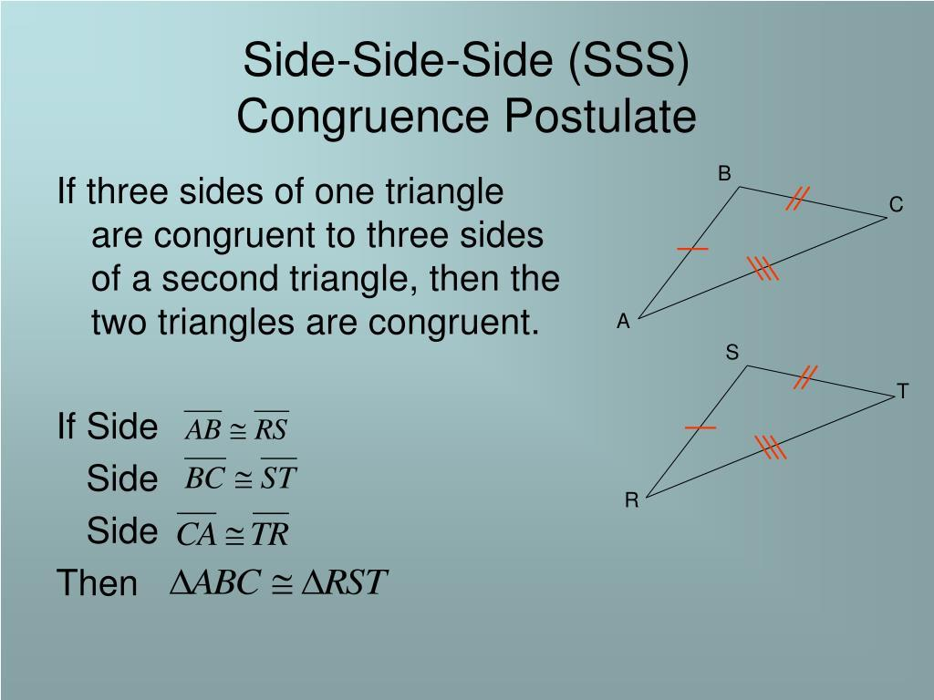

2. SAS — Side-Angle-Side
# Source: AI Source: Provided by: [Data Path: Persons Table -> ID Column: 1, Name_En Column: Motasem Essam] -> From: [ChatGPT] on [7/25/2026]
Two triangles are congruent if two corresponding sides and the included angle are equal.
$$\boxed{SAS}$$
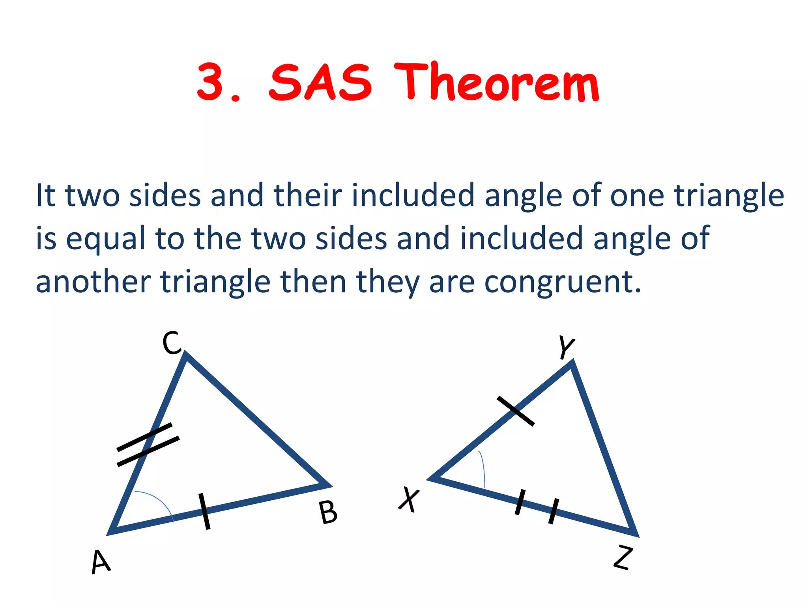
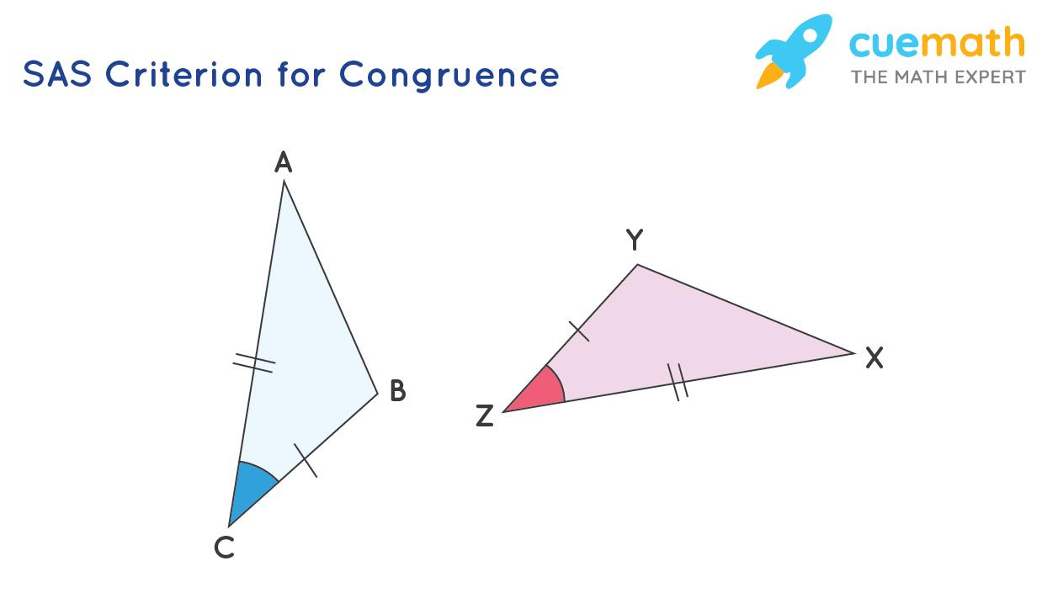
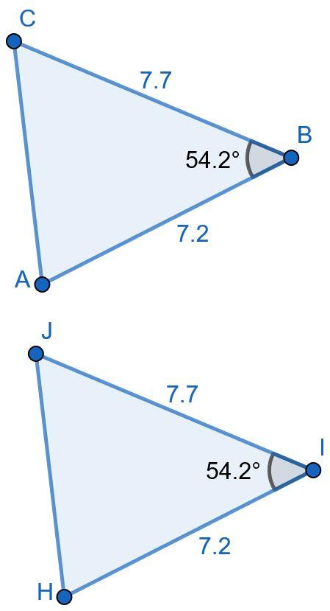
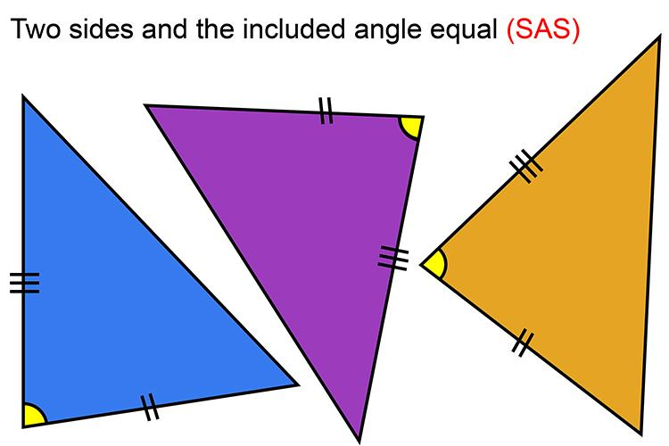

3. ASA — Angle-Side-Angle
# Source: AI Source: Provided by: [Data Path: Persons Table -> ID Column: 1, Name_En Column: Motasem Essam] -> From: [ChatGPT] on [7/25/2026]
Two triangles are congruent if two corresponding angles and the included side are equal.
$$\boxed{ASA}$$
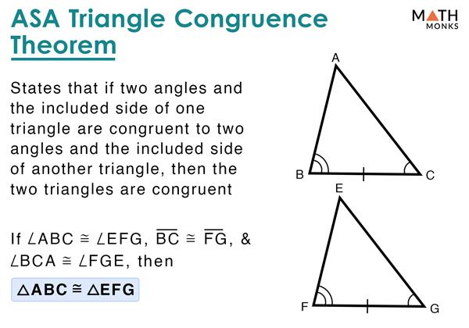
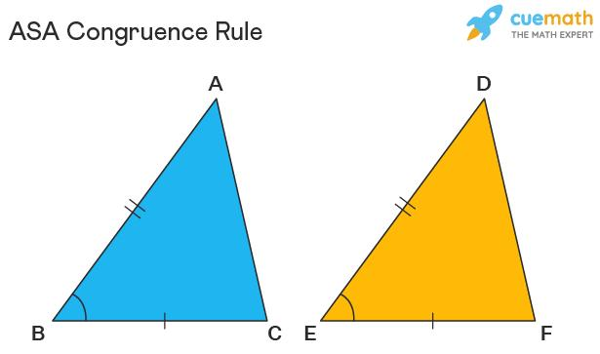
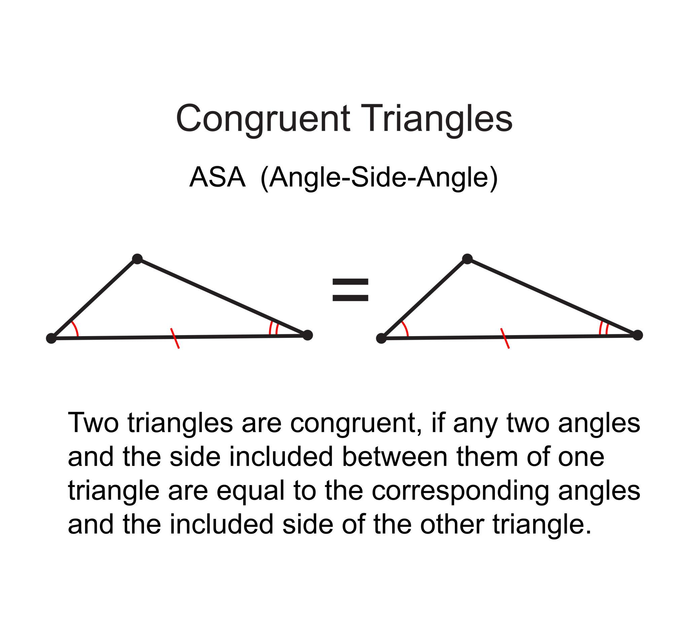
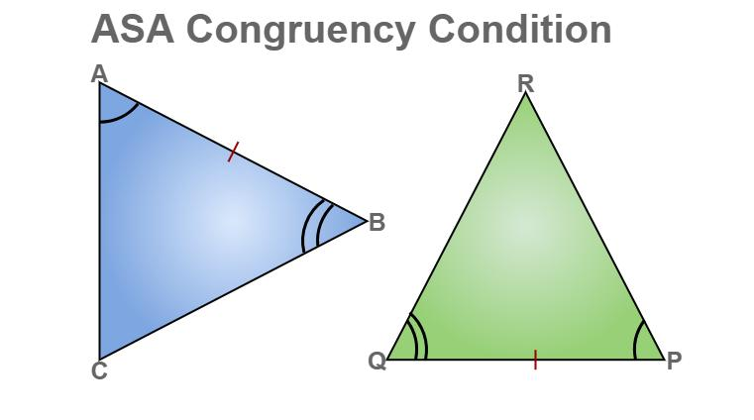
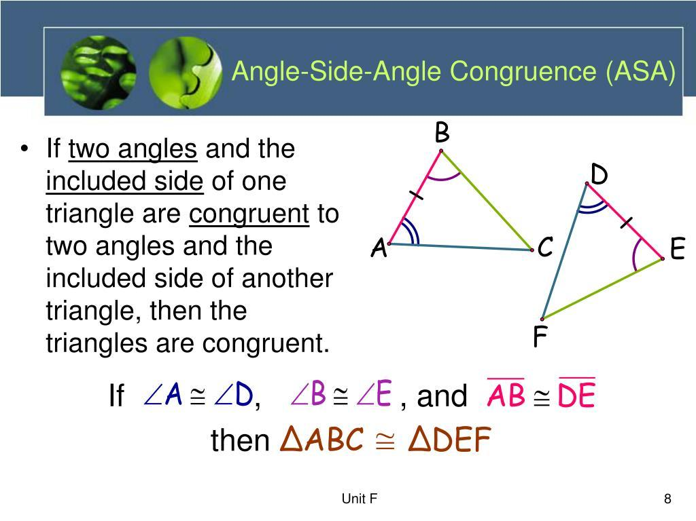

4. AAS — Angle-Angle-Side
# Source: AI Source: Provided by: [Data Path: Persons Table -> ID Column: 1, Name_En Column: Motasem Essam] -> From: [ChatGPT] on [7/25/2026]
Two triangles are congruent if two corresponding angles and a corresponding non-included side are equal.
$$\boxed{AAS}$$
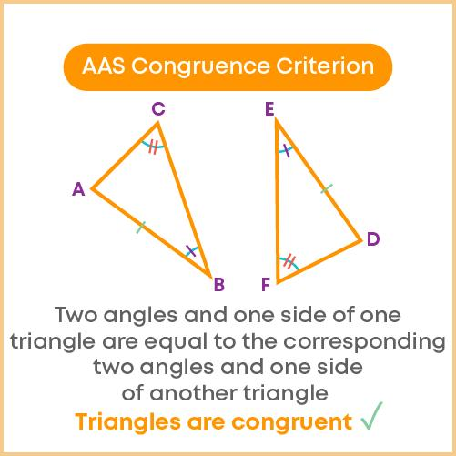
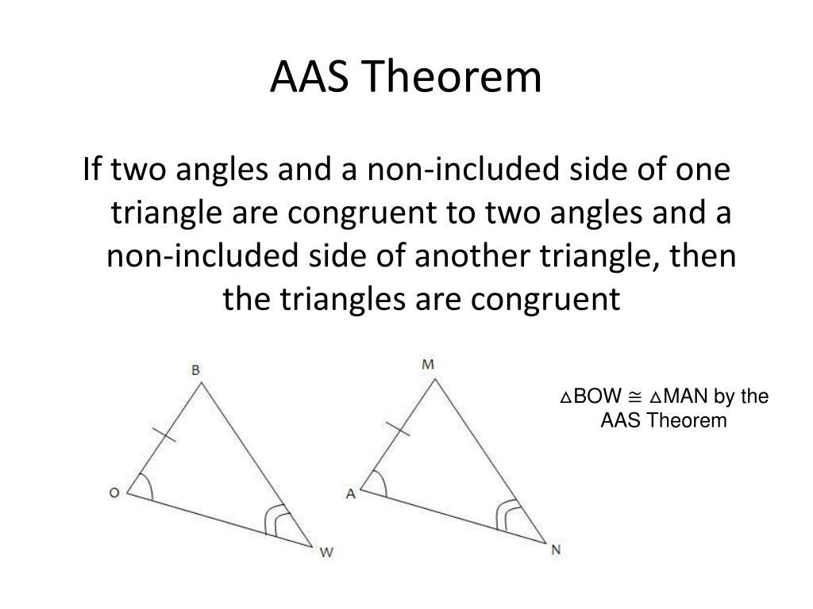
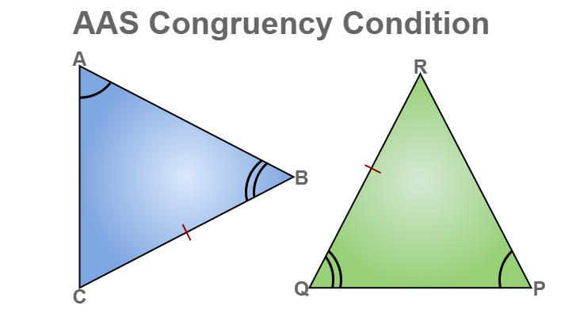
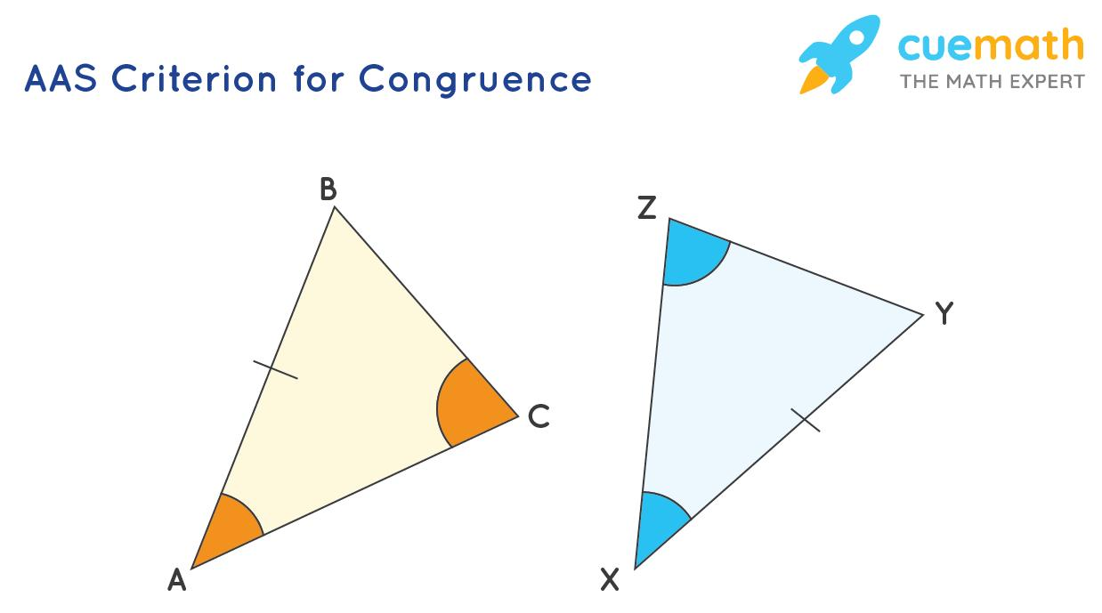
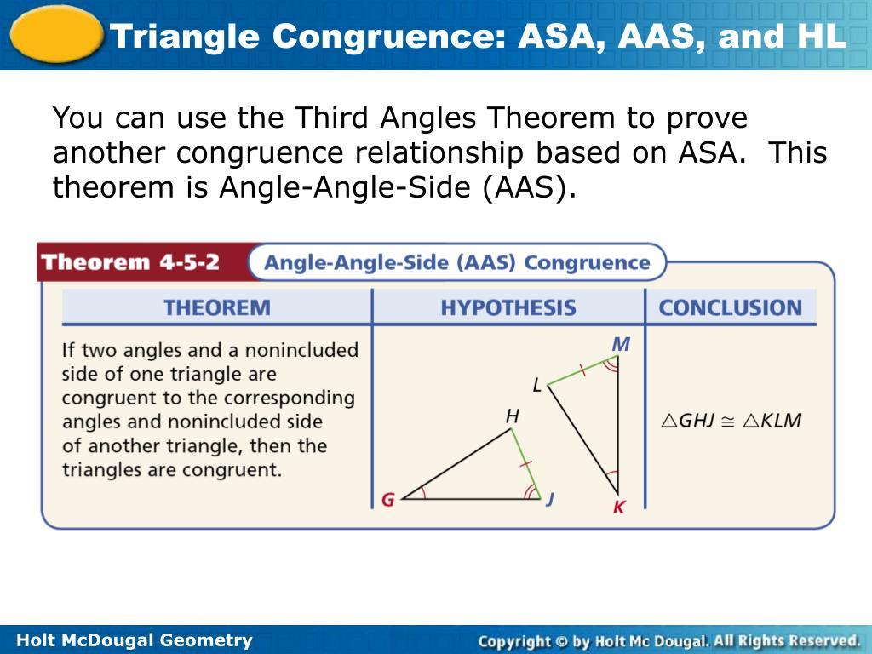

5. HL — Hypotenuse-Leg
# Source: AI Source: Provided by: [Data Path: Persons Table -> ID Column: 1, Name_En Column: Motasem Essam] -> From: [ChatGPT] on [7/25/2026]
For right triangles, two triangles are congruent if their hypotenuses and one corresponding leg are equal.
$$\boxed{HL}$$
It is also called:
$$\boxed{RHS}$$
(Right angle–Hypotenuse–Side) in some curricula.
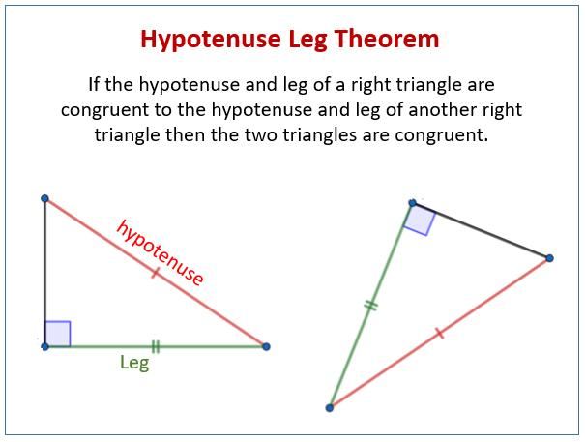
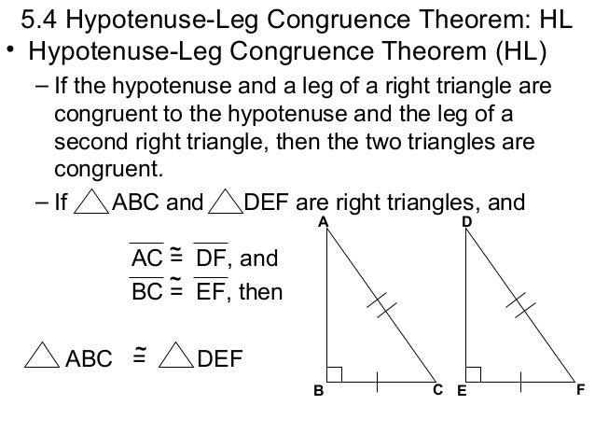
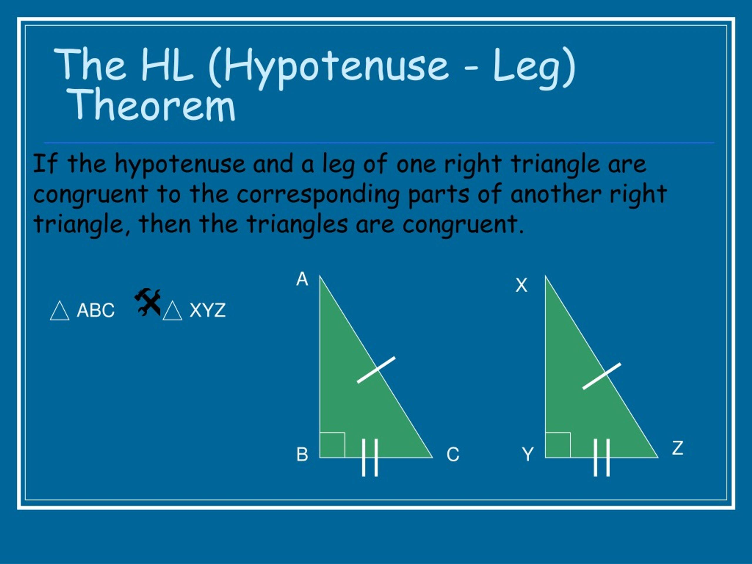
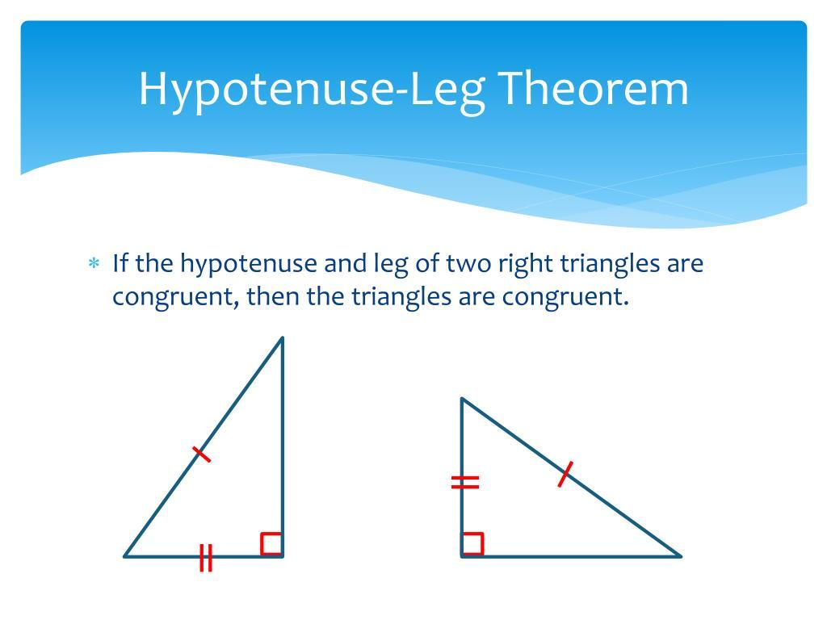
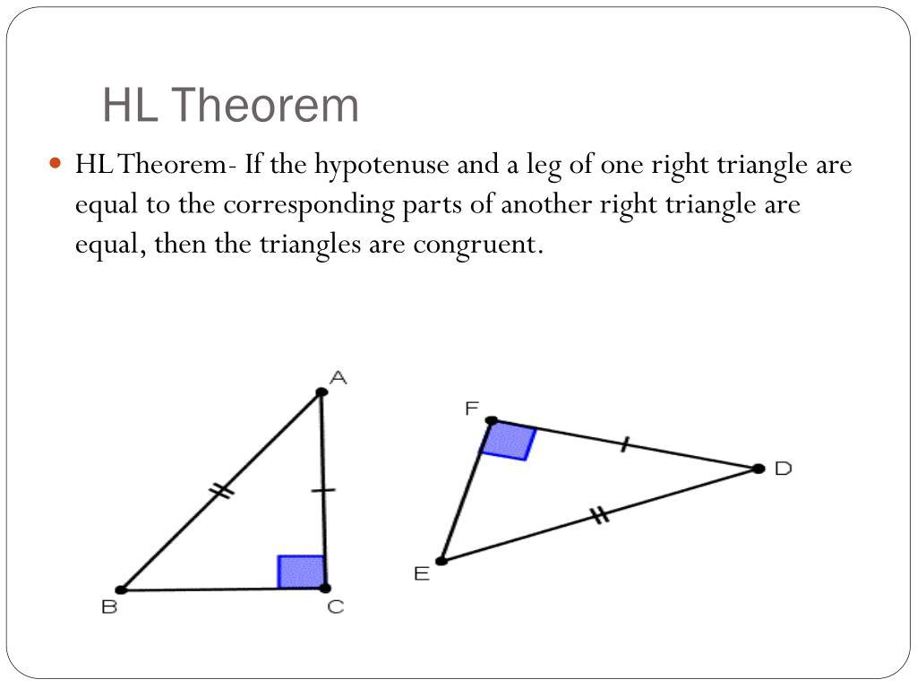

Congruence of Polygons
# Source: AI Source: Provided by: [Data Path: Persons Table -> ID Column: 1, Name_En Column: Motasem Essam] -> From: [ChatGPT] on [7/25/2026]
Two polygons are congruent if:
- They have the same number of corresponding sides.
- Corresponding side lengths are equal.
- Corresponding angles are equal.
- They have exactly the same shape and size.
For example:
$$\boxed{ABCD≅EFGH}$$
means that quadrilateral $ABCD$ and quadrilateral $EFGH$ are congruent.
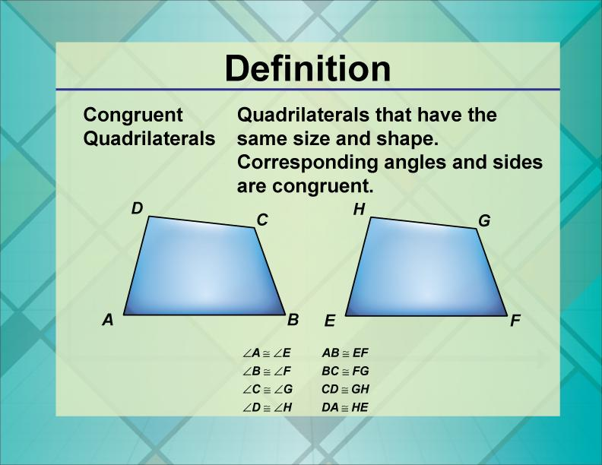
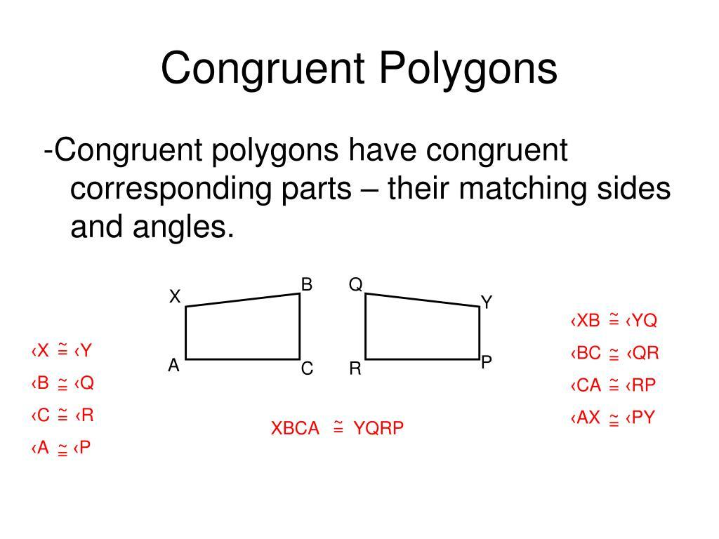
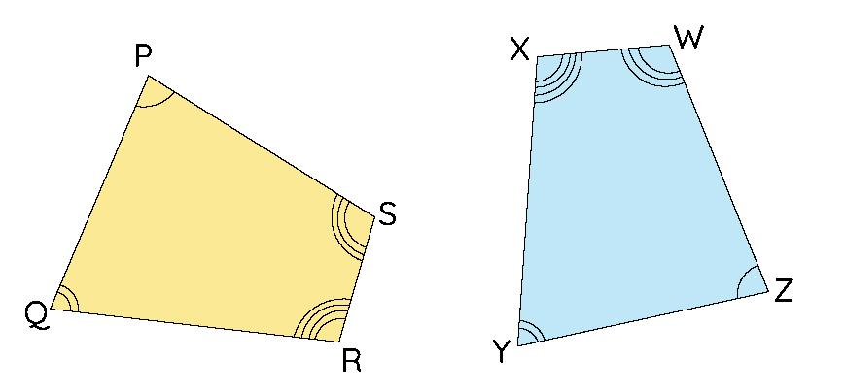
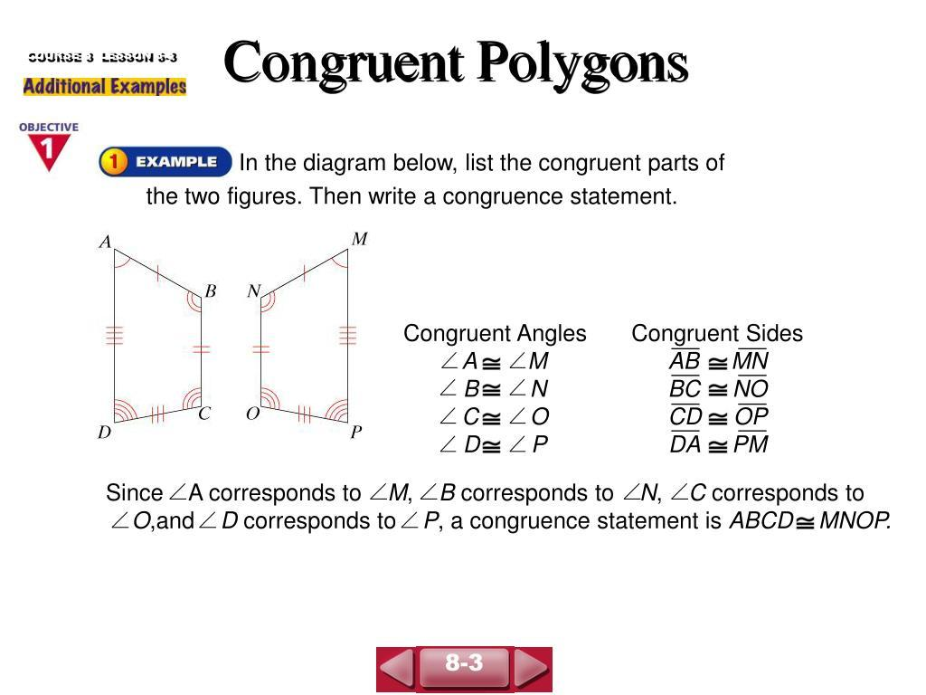
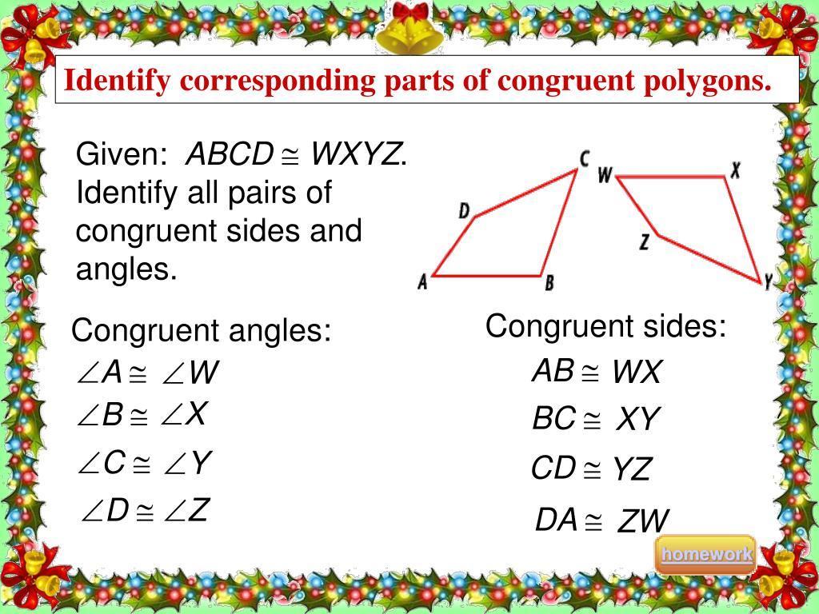
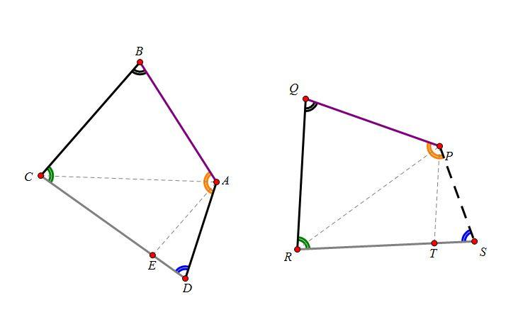

Congruence and Area
# Source: AI Source: Provided by: [Data Path: Persons Table -> ID Column: 1, Name_En Column: Motasem Essam] -> From: [ChatGPT] on [7/25/2026]
Congruent figures always have equal areas.
If:
$$A≅B$$
then:
$$\boxed{\text{Area}\left(A\right)=\text{Area}\left(B\right)}$$
For example, two congruent rectangles with dimensions $5×3$ have:
$$A=5×3=15$$
so both have area:
$$15\text{ square units}$$

Congruence and Perimeter
# Source: AI Source: Provided by: [Data Path: Persons Table -> ID Column: 1, Name_En Column: Motasem Essam] -> From: [ChatGPT] on [7/25/2026]
Congruent figures also have equal perimeters.
If:
$$A≅B$$
then:
$$\boxed{P_{A}=P_{B}}$$
because all corresponding side lengths are equal.

Congruence vs Similarity
# Source: AI Source: Provided by: [Data Path: Persons Table -> ID Column: 1, Name_En Column: Motasem Essam] -> From: [ChatGPT] on [7/25/2026]
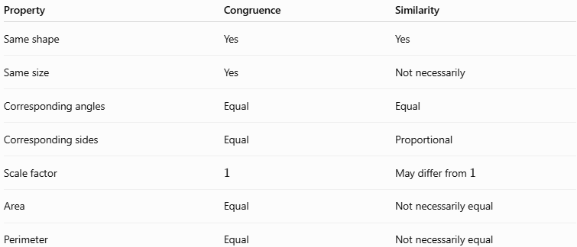
Property | Congruence | Similarity
Same shape | Yes | Yes
Same size | Yes | Not necessarily
Corresponding angles | Equal | Equal
Corresponding sides | Equal | Proportional
Scale factor | $$1$$ | May differ from $1$
Area | Equal | Not necessarily equal
Perimeter | Equal | Not necessarily equal
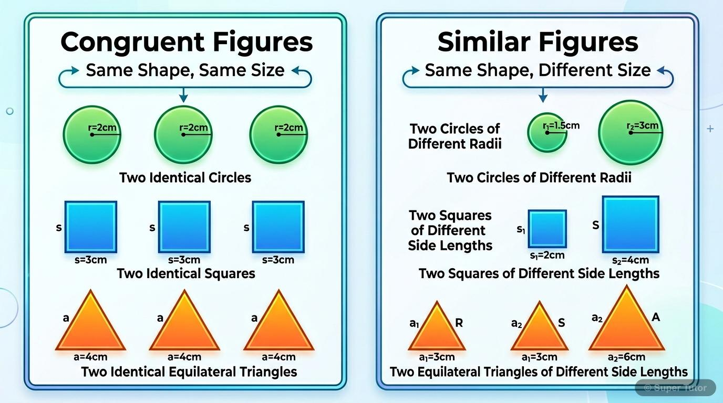
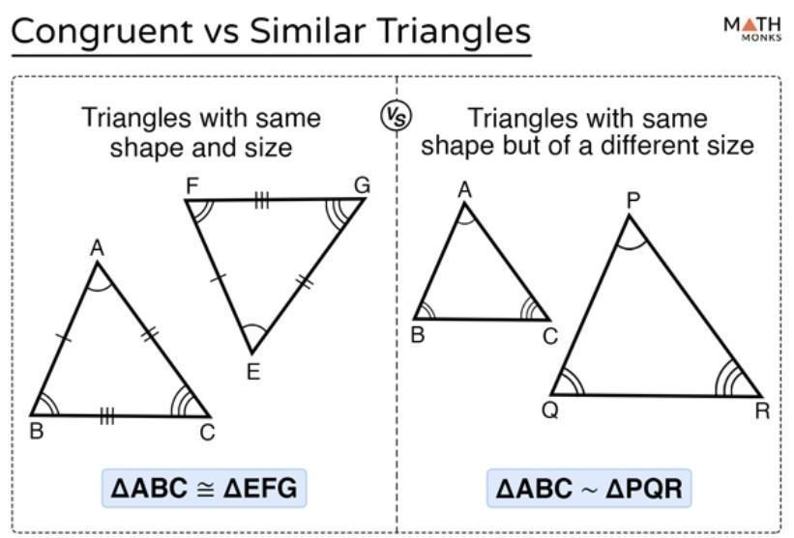
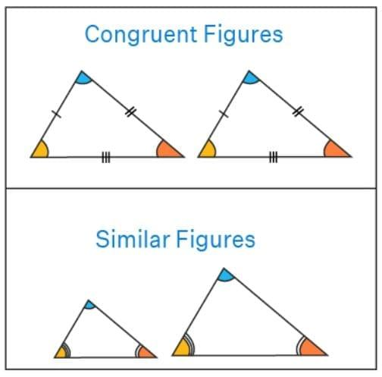
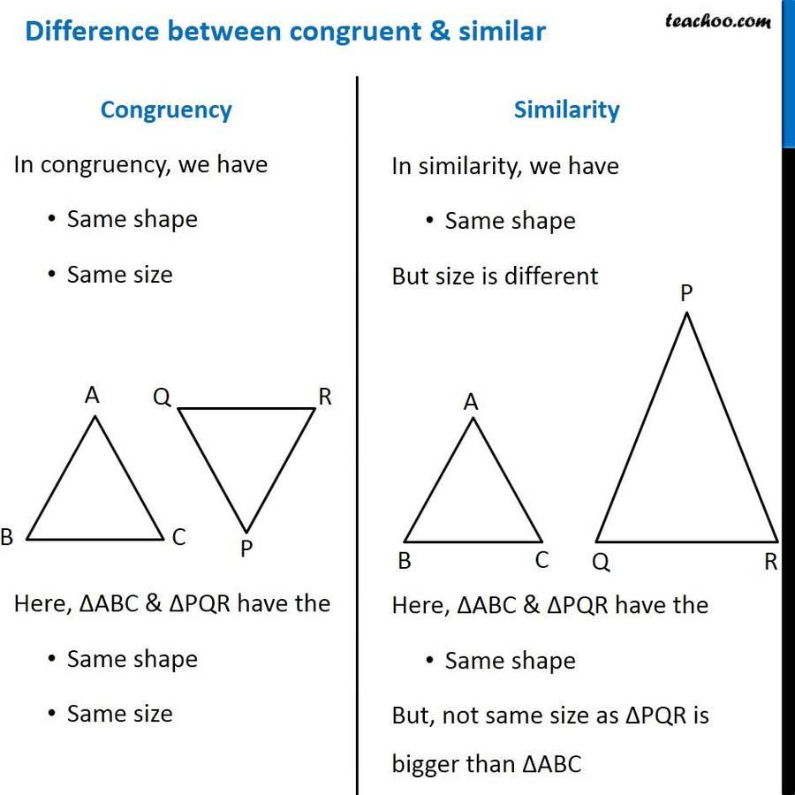
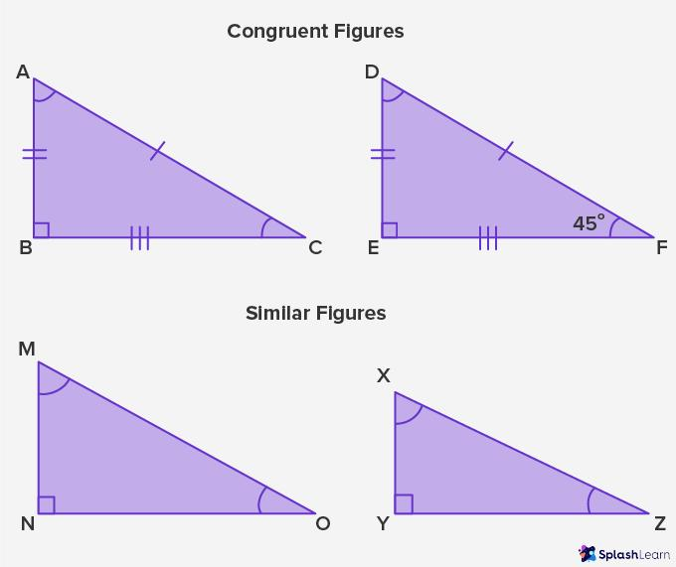

Congruence vs Equality
# Source: AI Source: Provided by: [Data Path: Persons Table -> ID Column: 1, Name_En Column: Motasem Essam] -> From: [ChatGPT] on [7/25/2026]
These concepts are related but are not exactly the same.
Equality
Usually refers to quantities having the same value.
For example:
$$5=5$$
Congruence
Refers specifically to geometric figures having the same shape and size.
For example:
$$△ABC≅△DEF$$

Congruence and Symmetry
# Source: AI Source: Provided by: [Data Path: Persons Table -> ID Column: 1, Name_En Column: Motasem Essam] -> From: [ChatGPT] on [7/25/2026]
Symmetry can also be understood through congruence.
When a figure is reflected across a line of symmetry, the resulting image is congruent to the original figure.
Similarly, a rotation of a figure produces a congruent image.
Thus:
$$\boxed{\text{Symmetry involves congruent images}}$$
in these cases.
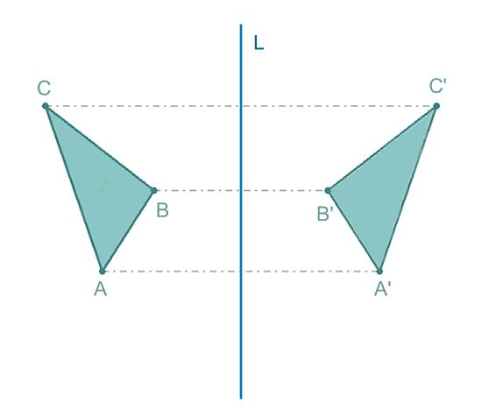
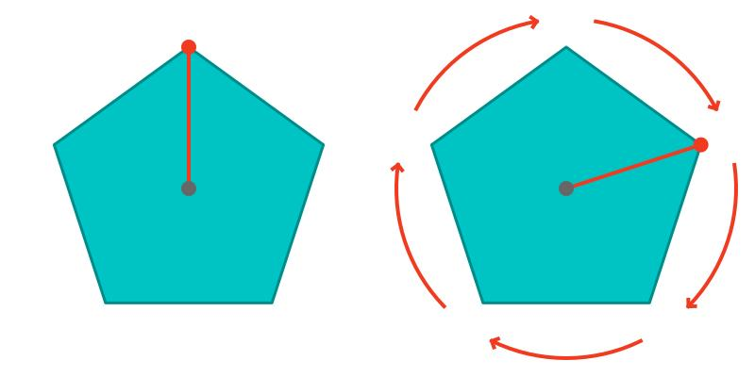
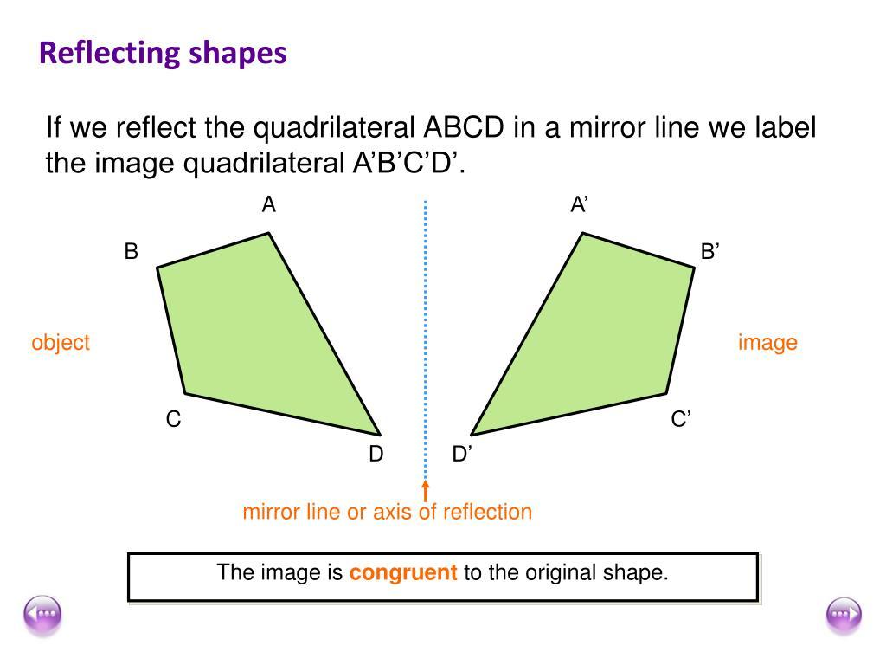
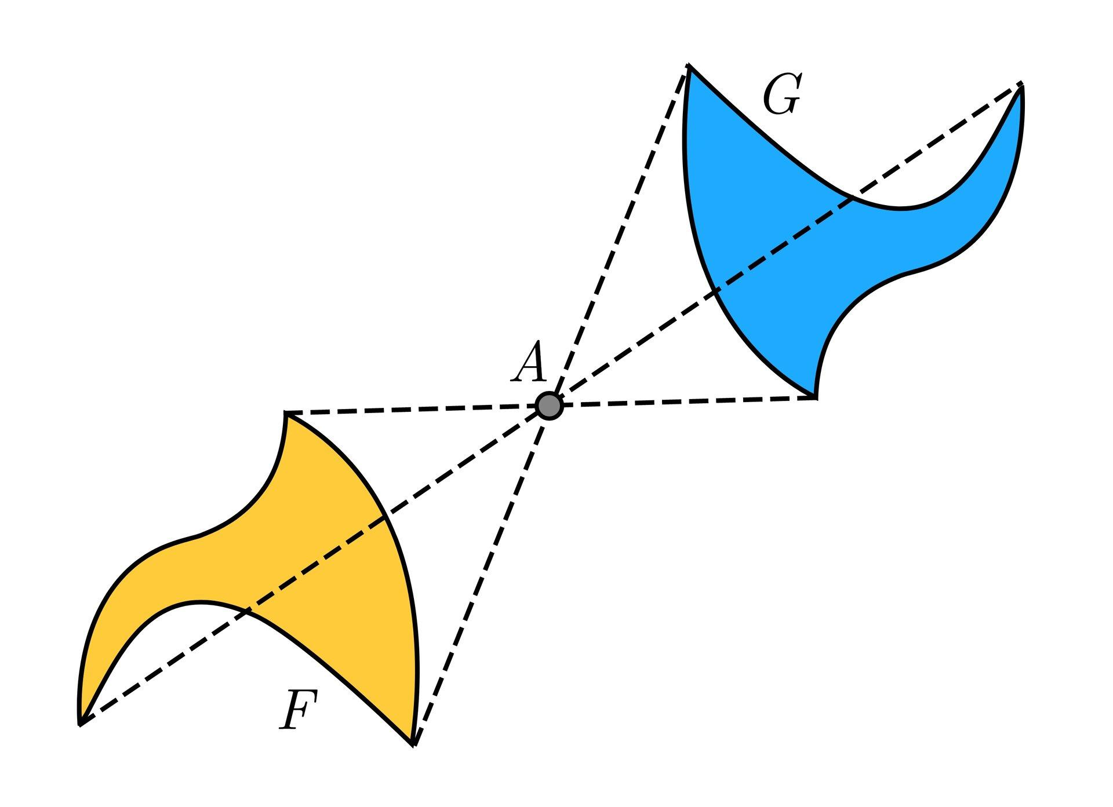
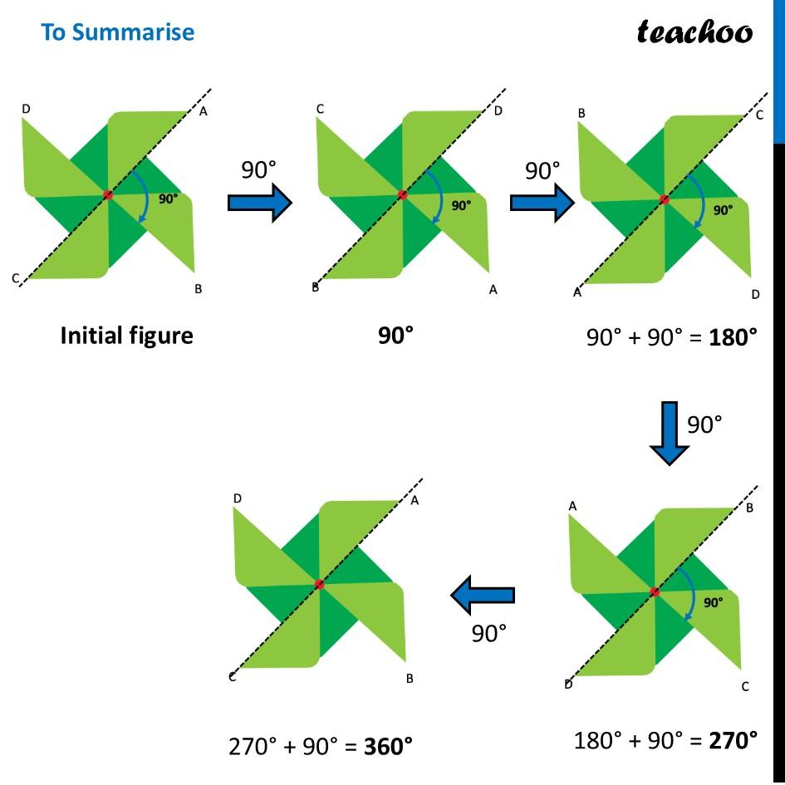

Real-World Examples
# Source: AI Source: Provided by: [Data Path: Persons Table -> ID Column: 1, Name_En Column: Motasem Essam] -> From: [ChatGPT] on [7/25/2026]
Congruence appears in:
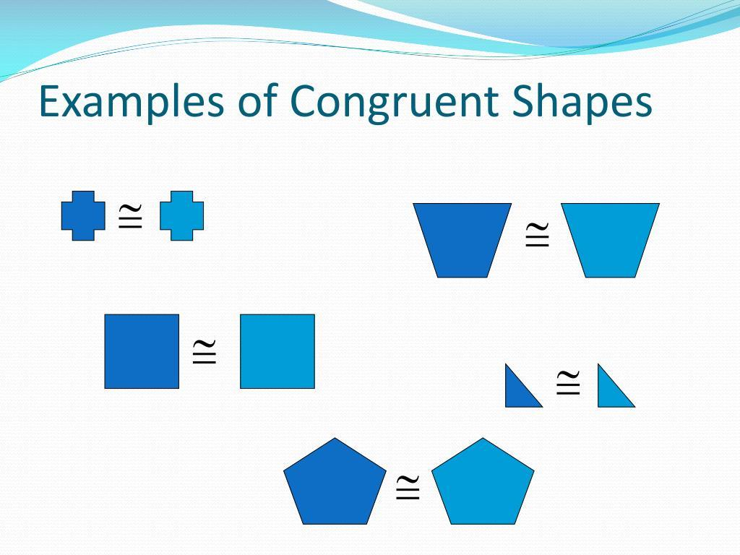
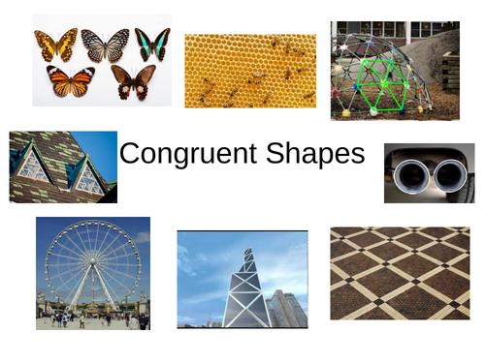

- Identical machine components.
- Repeated building elements.
- Tiles with identical shapes and dimensions.
- Manufacturing parts.
- Architectural patterns.
- Engineering structures.
- Computer graphics.
- Repeated product components.
For example, two manufactured bolts designed to have exactly the same dimensions can be considered congruent geometric models.

Applications
# Source: AI Source: Provided by: [Data Path: Persons Table -> ID Column: 1, Name_En Column: Motasem Essam] -> From: [ChatGPT] on [7/25/2026]
Congruence is important in:
- Plane Geometry
- Triangle Geometry
- Polygon Geometry
- Construction
- Architecture
- Engineering
- CAD
- Manufacturing
- Computer Graphics
- Surveying
- Design

Advantages
# Source: AI Source: Provided by: [Data Path: Persons Table -> ID Column: 1, Name_En Column: Motasem Essam] -> From: [ChatGPT] on [7/25/2026]
Studying congruence helps to:
- Compare geometric figures precisely.
- Prove that figures have identical dimensions.
- Solve triangle problems.
- Establish geometric theorems.
- Analyze symmetry.
- Verify engineering designs.
- Determine unknown lengths and angles.
- Simplify geometric constructions.

Limitations
# Source: AI Source: Provided by: [Data Path: Persons Table -> ID Column: 1, Name_En Column: Motasem Essam] -> From: [ChatGPT] on [7/25/2026]
Congruence:
- Requires figures to have exactly the same size and shape.
- Does not apply when corresponding lengths are only proportional.
- Does not describe enlargement or reduction.
- Can require several conditions to prove, especially for complex polygons.
- Small measurement errors in real objects can make exact congruence difficult to establish physically.

Mathematical Representation
# Source: AI Source: Provided by: [Data Path: Persons Table -> ID Column: 1, Name_En Column: Motasem Essam] -> From: [ChatGPT] on [7/25/2026]
If two figures $F_{1}$ and $F_{2}$ are congruent:
$$\boxed{F_{1}≅F_{2}}$$
For corresponding points:
$$A↔A' \\ B↔B' \\ C↔C'$$
Corresponding lengths satisfy:
$$AB=A'B'$$
and corresponding angles satisfy:
$$∠A=∠A'$$

Key Points
# Source: AI Source: Provided by: [Data Path: Persons Table -> ID Column: 1, Name_En Column: Motasem Essam] -> From: [ChatGPT] on [7/25/2026]
- Congruence means same shape and same size.
- The symbol for congruence is:
$$\boxed{≅}$$
- Congruent figures may have different positions or orientations.
- Translation, rotation, and reflection preserve congruence.
- Congruent line segments have equal lengths.
- Congruent angles have equal measures.
- Congruent figures have equal corresponding sides and angles.
- Congruent figures have equal area and perimeter.
- Important triangle congruence criteria include:
  - SSS
  - SAS
  - ASA
  - AAS
  - HL/RHS
- Congruence is different from similarity because similarity allows a change in size.

Conclusion
# Source: AI Source: Provided by: [Data Path: Persons Table -> ID Column: 1, Name_En Column: Motasem Essam] -> From: [ChatGPT] on [7/25/2026]
Congruence is one of the fundamental types of Geometric Relationships. Two geometric figures are congruent when they have exactly the same shape and size, regardless of their position or orientation. Congruence is closely connected to rigid transformations, including translation, rotation, and reflection. In triangle geometry, criteria such as SSS, SAS, ASA, AAS, and HL provide methods for proving congruence. The concept is essential for comparing geometric figures, proving theorems, analyzing symmetry, and solving problems in geometry, engineering, architecture, CAD, manufacturing, and design.

